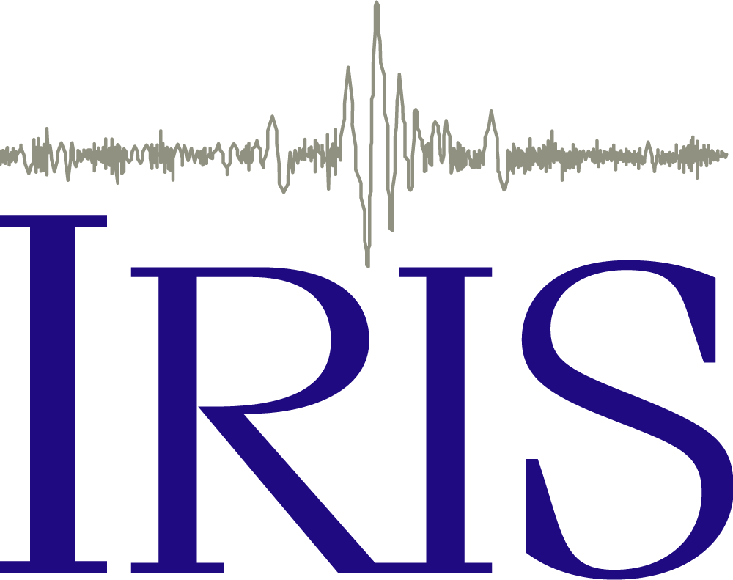 Listening to the Earth

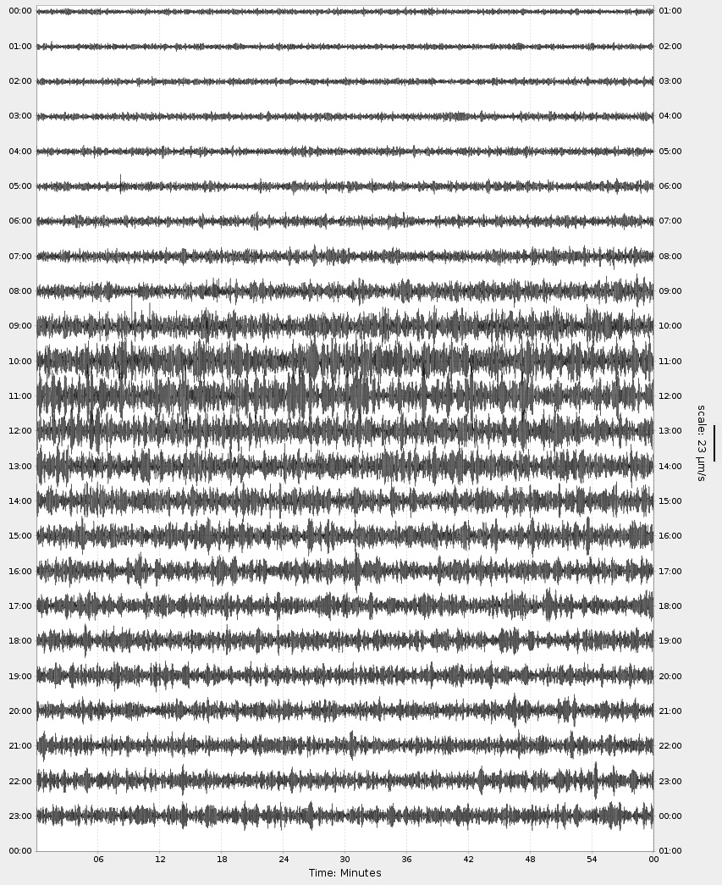
The figure below illustrates 24 hours of ground motion recorded at a seismic station (SJG) in Puerto Rico in September of 2017. (https://www.iris.edu/app/station_monitor/#2017-09-20/IU-SJG/webicorder/). Each line represents one hour, with midnight September 20, 2017 on the top line, and 11pm at the beginning of the last line, ending at midnight September 21. All times are in UTC, Coordinated Universal Time, the primary time standard by which the world regulates clocks and time. It is within about 1 second of mean solar time at 0° longitude (Greenwich, England), and is not adjusted for daylight saving time.
1:00 UTC
12:59 UTC
12:00 UTC

Look carefully at the data. What do you notice about the recorded signal throughout the day? In the space below, describe how the signal changes from the beginning to the end of September 20th.

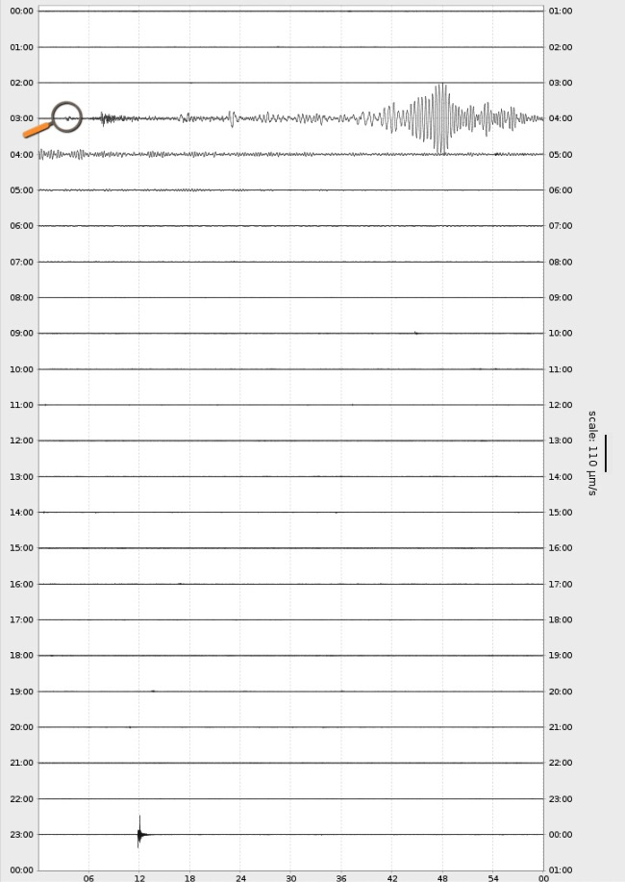
At the right is another 24-hour recording from the same station on March 25, 2020. At just after 3:00 UTC the data shows the ground motion resulting from a M 7.5 earthquake arriving. In the space below, compare and contrast this recording to the recording you looked a previously?

For a refresher on wave amplitude- check out this description: https://flexbooks.ck12.org/cbook/ck-12-middle-school-physical-science-flexbook-2.0/section/16.5/primary/lesson/wave-amplitude-ms-ps

https://www.iris.edu/app/station_monitor/#2020-03-25T02:49:20/IU-SJG/webicorder/IU-SJG|11202357

What you are seeing in the seismic data
Seismometers record vibrations from a variety of sources other than earthquakes. While many such recordings include ground motion resulting from human activity such as trains, explosions, or even excited sports fans, other natural events, such as severe weather can also cause the ground to move. On September 20, 2017 the Category 4 Hurricane Maria crossed over the island of Puerto Rico with 155 mile per hour winds. The seismic station we have been discussing (SJG) is labeled with a red star on the map. The eye of the hurricane followed the yellow dotted path through Puerto Rico at approximately 10 MPH, passing very near the seismic station.

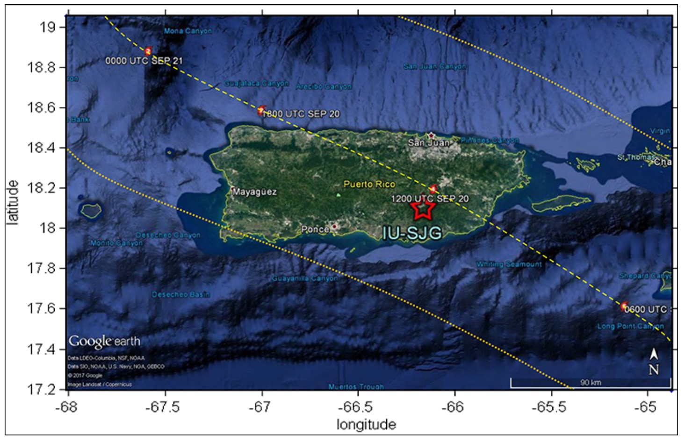
Image from Wilson, D. C., P. Davis, C. Ebeling, C. R. Hutt, and K. Hafner (2018), Seismic sensors record a
hurricane’s roar, Eos, 99, https://doi.org/10.1029/2018EO102963. Published on 03 August 2018.
https://eos.org/science-updates/seismic-sensors-record-a-hurricanes-roar

How can a Hurricane make the ground move?
Hurricanes don’t have to make landfall in order to be noticed by seismometers. Watch this animation to learn more https://www.youtube.com/watch?v=QMA3Ze2vqN8
(https://www.iris.edu/hq/inclass/animation/576)

Based on what you learned from the animation, how does a hurricane that is still miles offshore cause the ground to move at an on-land seismic station?

However, in Puerto Rico, the seismic station not only measured wave action, the storm passed directly over the seismic station! Some facts about Hurricanes:

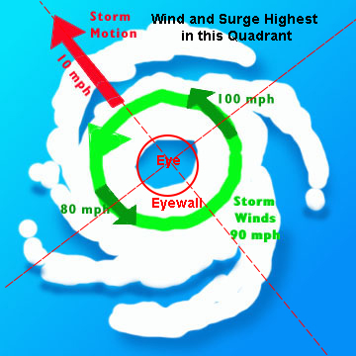
- The eye wall (the area immediately outside the eye of a hurricane, associated with tall clouds) is comprised of the strongest winds and the heaviest precipitation

- Winds and surge are usually the most intense in the right front quadrant of the storm where wind speeds combine with the speed of the storm’s movement. In other words, the most intense winds are just ahead and to the right of the eye of the storm.

- Hurricanes are rated on the Saffir-Simpson Hurricane Wind Scale, which includes five categories based on the storm's sustained wind speeds. If a storm is a Category 3, 4 or 5, it is deemed a "major" hurricane due to the potential for significant loss of life and damage. Hurricanes that fall into categories 1 or 2 are still considered dangerous.

Look back to the seismic data from the day that Hurricane Maria crossed Puerto Rico. What hours appear to show the strongest winds when the eye wall was closest to the location of the seismic station? What time do you estimate the eye wall made landfall? Be sure to include evidence from the data and justification from your understanding of hurricanes in your response.

Refer back to the map of Puerto Rico on page 3. Notice the four small red and yellow dots along the yellow dotted path of the hurricane’s eye. They mark the position of the eye of the hurricane at four times, 6 hours apart each, during the day on September 20th. The first in the lower right corner was the position of the hurricane’s eye at 0600 UTC, followed by 1200 UTC, 6:00pm UTC, and 1200 UTC on September 21st. These track along the hurricane’s path as it moved to the northwest. How close was your estimate, based on the seismic data and your knowledge of hurricanes, of when Hurricane Maria was closest to the seismic station?

Case Study
Choose one of the following hurricanes, look at data from the nearest seismic station on the date of closest approach to answer the questions below. Note: To get the best view of the hurricane, you may need to use the forward and back arrows to change the data shown to one day earlier and one day later.
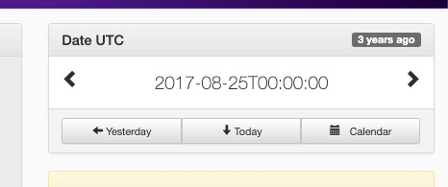
Hurricane Michael (2018)
https://www.iris.edu/app/station_monitor/#2018-10-10/US-BRAL/webicorder/

Hurricane Irma (2017)
https://www.iris.edu/app/station_monitor/#2017-09-10/N4-061Z/webicorder/

Hurricane Harvey (2017)
https://www.iris.edu/app/station_monitor/#2017-08-26/US-KVTX/webicorder/

Which hurricane did you choose?

Based on the seismic data on the day the hurricane was nearest to the seismic station chosen, what hours were the strongest winds of the eye wall closest to the location of the seismic station?

Just using the seismic data, would you estimate this hurricane was bigger or smaller than the Category 4 Hurricane Maria that we started this exercise with? Be sure to include evidence from the data and justification from your understanding of hurricanes in your response.

The 2020 Atlantic hurricane season began on Monday, June 1 and ends on Monday, November 30. An above-normal 2020 Atlantic hurricane season is expected, according to forecasters with NOAA's Climate Prediction Center, a division of the National Weather Service.

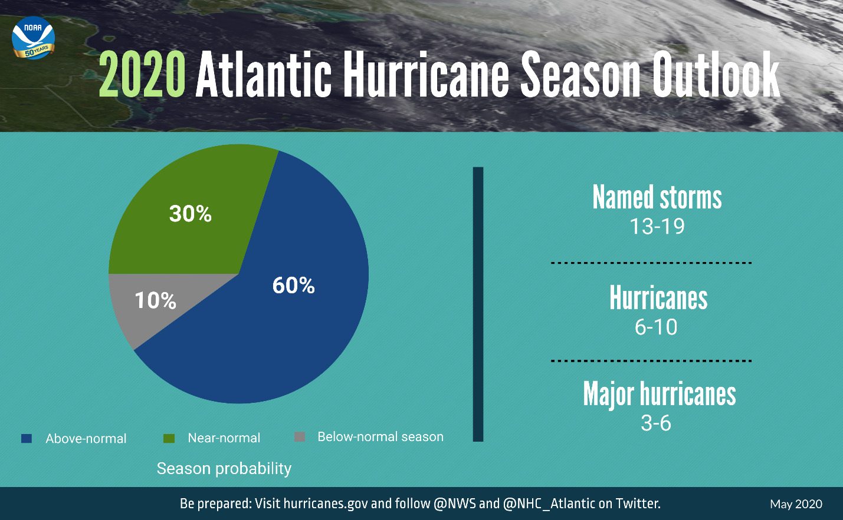

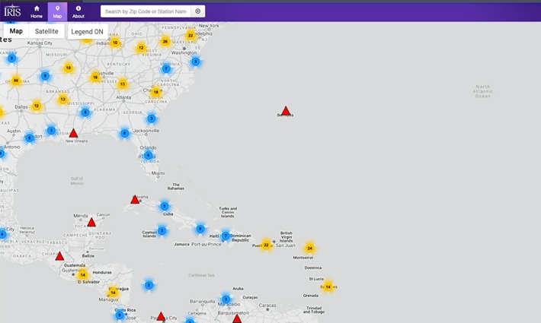
Throughout hurricane season, remember to check the IRIS Station Monitor to choose some stations and monitor the ground for approaching storms!

All of the colored dots on the map on the right from the IRIS Station Monitor represent seismometers with real-time seismic data online!

https://www.iris.edu/app/station_monitor/#Today//map/

