Find your BIRTHQUAKE!

Before
How often do you think an earthquake occurs? (Circle One)

- Many times per day
- Once a day
- Every other day
- Weekly
- Monthly
- Annually

Briefly explain the reasoning you used when choosing your answer above.

Where do you think earthquakes occur? In the US? Globally?

On any given day, such as your birthday, do you think there would be more large earthquakes or small earthquakes?

Activity - Find your BIRTHQUAKE!
The IRIS Earthquake Browser (IEB) can help you find your Birthquake. IEB is an interactive map for displaying selections of up to 25,000 seismic event epicenters (normally earthquakes) on a map of the world. There are millions of events to choose from going back to the 1960s.
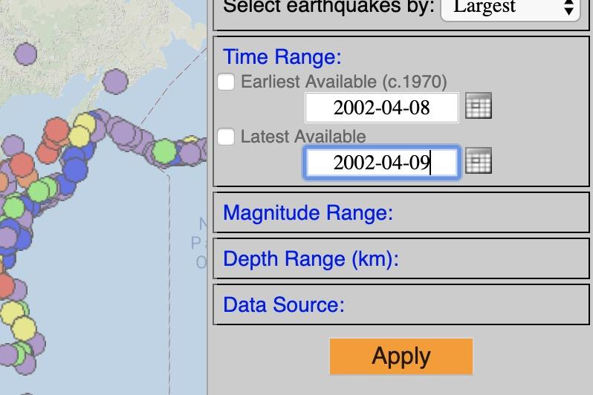
- Go to www.iris.edu/ieb.
- In the upper right hand corner, click on Time Range to open the box.
- Uncheck the “Earliest Available” box and enter your birth date in the format YYYY-MM-DD
- Uncheck the “Latest Available” box and enter the date for the day after your birthday in the format YYYY-MM_DD.
- Click [Apply]

Check the earthquake count box. This tells you how many events met your search criteria and how many are displayed on the screen. How many earthquakes occurred on your birthday?

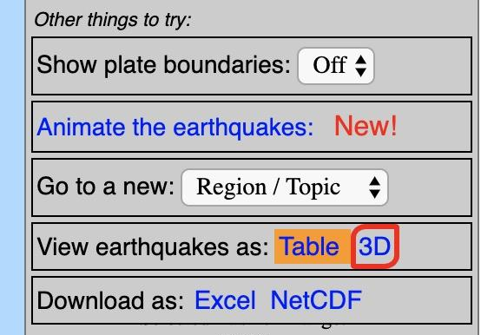
Your Birthquake is the largest magnitude event that occured on your birthday. Find your birthquake by displaying all the earthquakes from the map as a table.
- Do this by finding “View earthquakes as” in the right hand menu, and click on [Table].
- This will display your search results in a sortable table that opens in a new tab.
- Sort so the largest event is on top by clicking the [Mag] column twice (note: clicking once puts the smallest on top, clicking the second time reverses the order).
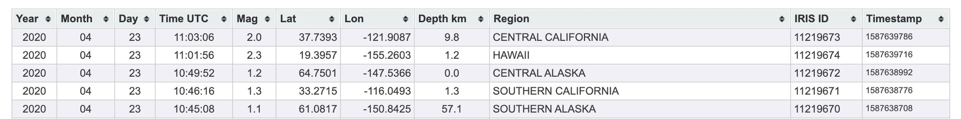

Complete the following about your Birthquake

Date:
Time:
Magnitude:
Depth:
Region:

What was the smallest earthquake that occured on your birthday?

Date:
Time:
Magnitude:
Depth:
Region:

Hmm… do events like these occur regularly? Find out by exploring at least two other days in IEB. How many events occured on each? What was the largest event for each? What was the smallest for each? Describe your results in the space below.

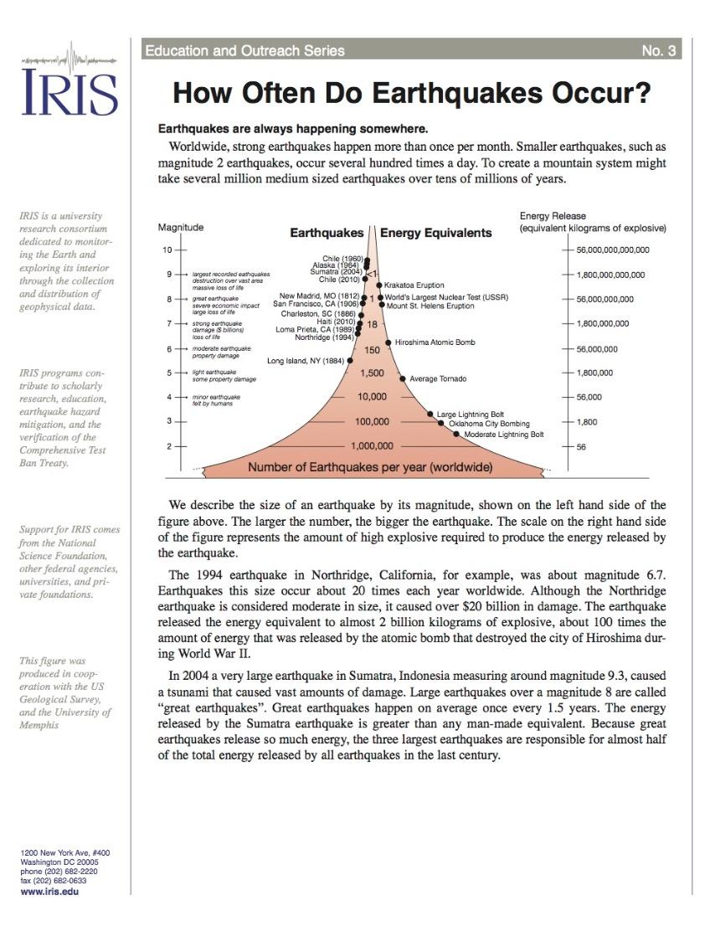
Next, read more about How Often earthquakes Occur (https://www.iris.edu/hq/inclass/fact-sheet/153).

- Describe how what you read either supports, refutes, or is inconclusive compared to your answer above to the question... “do events like these occur regularly”.

Summarize the relationship between the size of earthquakes and the frequency with which they occur globally?

According to the diagram in the reading, what is the closest energy equivalent for your Birthquake?

Finally, let's learn about how the energy released from an earthquake scales for each level of magnitude.
- Watch the Pastaquake video (https://www.youtube.com/watch?reload=9&v=64Wzr2nFkUU).
- Based on the analogy used in the video, solve for how many strands of spaghetti your birthquake* would be equal to? Use the example below to help you.
* If your birthquake was less than M5.0, the math will get a little tricky. Thus, for simplicity, pretend your birthquake was a M6.2.

Example #1 - Let's assume that my birthquake is a M5.7 earthquake. We know from the video that in our analogy a M5 = 1 strand of spaghetti and that for each step up in Magnitude, we multiply the number of spaghetti pieces by 30.

This means that the number of spaghetti strands for a M6 = ______

Since my birthquakes (M5.7) is greater than M5 but less than M6, I know the number of spaghetti strands for my birthquake must be between _____ spaghetti strand(s) and ______ spaghetti strand(s). In fact, my birthquake is exactly 0.7 of the way between the two.

This means we can approximate how many strands of spaghetti my birthquake is by multiplying 0.7 (the distance between the min and max) by 30 spaghetti strands (or the max number of spaghetti strands). Thus…

0.7 x 30 spaghetti strands = 21 or My M5.7 birthquake would be equal to 21 strands of spaghetti using the analogy.

