Reading Seismograms: Part 1

Section 1 - Introduction

Unlocki₁ng₂ the secre₃t₄s of a seismogram₅…

_ _ s _or_ _han jus_ w_ggl_s
1 4 5 3 4 4 1 3

Solve the puzzle and write the mystery message below?

Section 2 - What do you already know about seismograms?
Watch the following video and answer the questions below.
(https://www.iris.edu/hq/inclass/animation/seismograms_of_common_events_compiled)
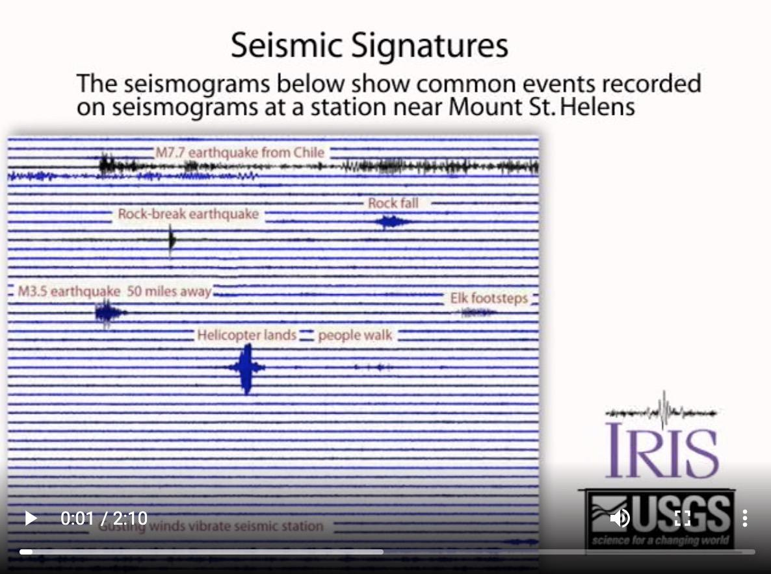
What do you think a seismogram is?

What information do you think it conveys?

What makes you think so?

Selection 3 - Let's Explore Further
As you probably discovered in the previous video, seismograms show how and to what degree the ground moves with the passage of time. However, how were those seismograms created? To get a better sense of that, let’s explore.

Watch this video and follow the instructions to do the following
(https://www.iris.edu/hq/inclass/video/build_your_own_seismograph_tutorial__part_15)

- On a separate piece of paper, design a seismometer to record ground motion (pay attention to the elements of an “excellent” design shown in the video).

- Build, test, and revise your design.

- Make a list of the things you used in your design and explain the role of each component. These animations might offer some helpful hints for your design..
  - https://www.iris.edu/hq/inclass/animation/seismograph_vertical
  - https://www.iris.edu/hq/inclass/animation/seismograph_horizontal

- Paste a photo of your design along with your list of components into the space below. Make sure you include your explanations for what each component does.

Now that you have created your own design, watch this video to explore the key components of a seismometer similar to the one you probably built.
(https://www.iris.edu/hq/inclass/video/build_your_own_seismograph_tutorial__part_25)

In the space below, compare and contrast your seismometer to the one shown in the video.

If you want to learn even more, this video explores the components of real seismometers used by scientists!
(https://www.iris.edu/hq/inclass/video/build_your_own_seismograph_tutorial__part_45)

Section 4 - Summarize your learning so far!
With each word worth 10 cents, write a $3.50 summary of the learning from the lesson. You must use the following five words (or 50 cents) in your response… mass, spring movement, seismometer, seismogram.

