Reading Seismograms: Part 2

This activity builds on ideas developed in Reading Seismograms: Part 1. If you missed it, Part 1 was released on May 1, 2020 and is available here.

Background:
Energy is released from an earthquake as seismic waves… P, S, and Surface waves.

- Watch this video (https://www.iris.edu/hq/inclass/video/seismic_waves_p_s_and_surface)!

Section 1: Reading the data
As you learned in Part 1, seismographs, like the one you created, record how the ground moves over time. That means the trace that you see on the seismogram corresponds with the actual movement of the ground. This seismogram is the recording of how the ground moved as waves from an earthquake arrived at a seismometer and moved the ground beneath it.
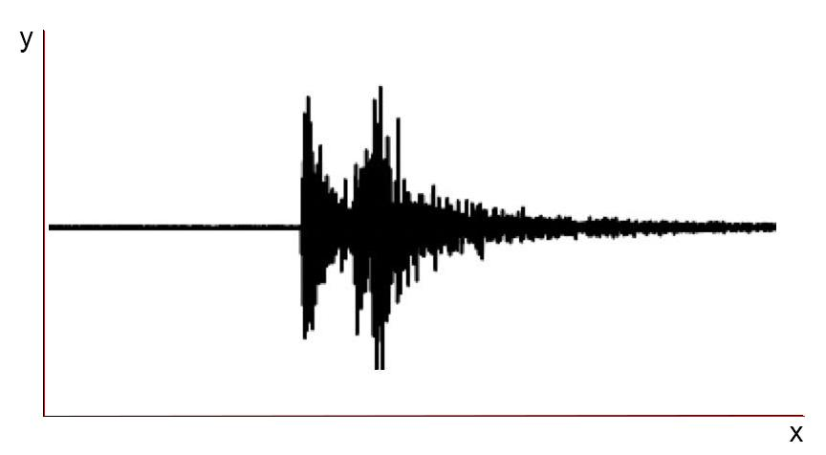

- On the seismogram above from last week, label the x-axis time and the y-axis ground displacement.

Let’s Explore!
Let's explore how different ground movements might affect the seismogram recorded.

Pretend that we have a vertical seismograph (https://www.iris.edu/hq/inclass/animation/seismograph_vertical). Examples 1 & 2 and seismograms 1 - 3 are simplified hand drawn seismograms. When describing these simplified seismograms we will use general descriptions of time and displacement (e.g. up a little, down a lot, a few seconds etc., instead of using specific amounts like up 50nm or 8.3 seconds).

Examples:
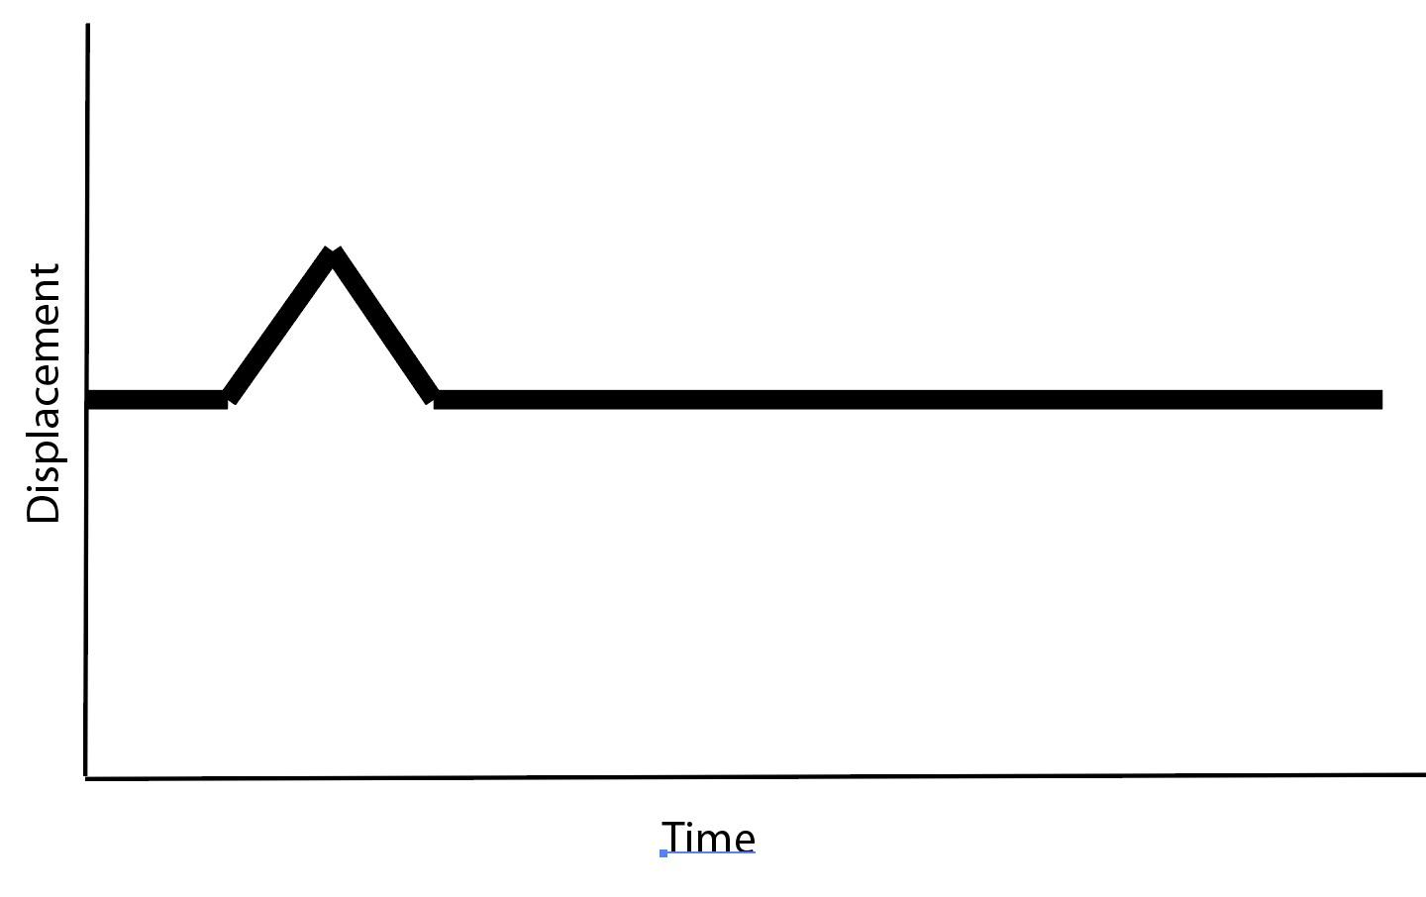
Example 1: The ground at the seismometer... moved up a little and then returned to its original position.

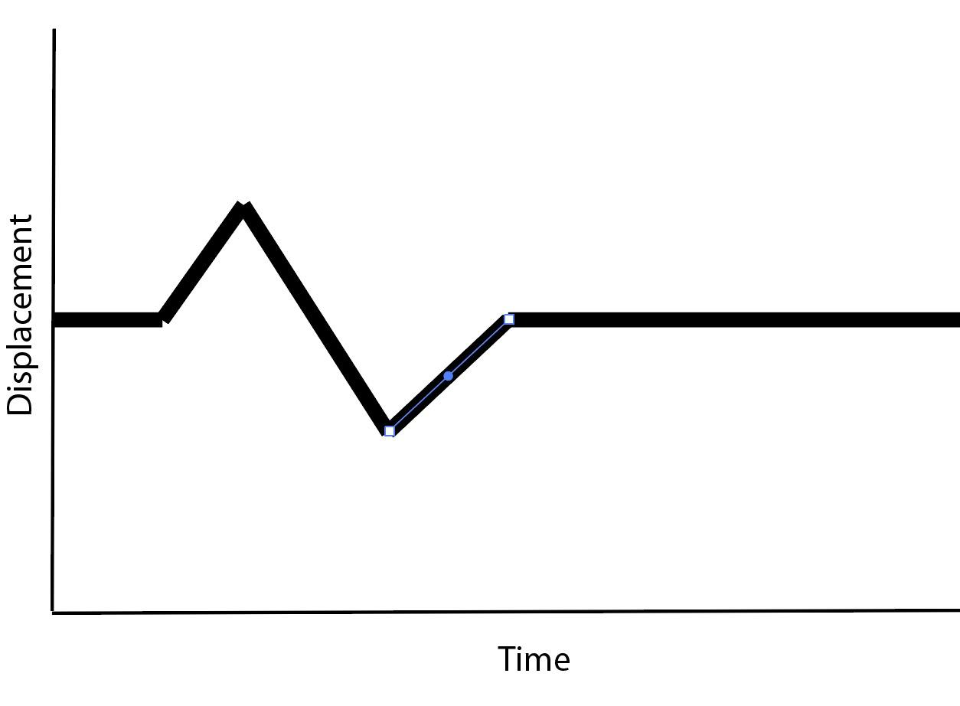
Example 2: The ground at the seismometer... moved up a little, then down past the original position a little, and then back to the original position.

- Now it is your turn! Look at the simplified seismograms below and describe the following seismograms. If you have a phone, or tablet, the free Hamm Seismograph app (Google Play/Apple Store) is a great choice for this activity*. Just download, open the app, select the Z (vertical) axis and hit start. Then you can try to make the seismogram by moving the phone or tablet. This may help you describe how the ground moved! .

*If the Hamm app doesn’t work on your device for some reason, you can also try the MyShake App (Google Play/Apple Store). When it opens goto More>Sensor and select Z (vertical) component.
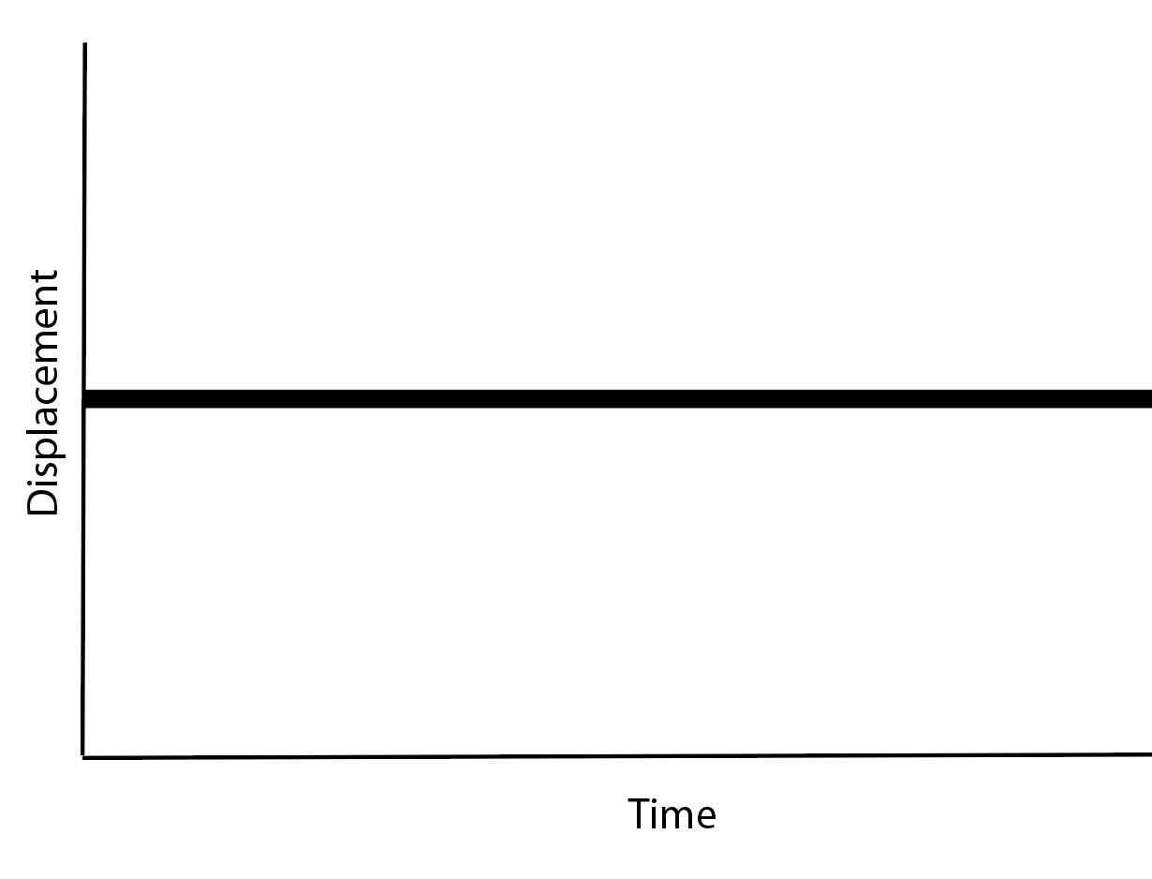
Seismogram 1: Finish the sentence. The ground at the seismometer...

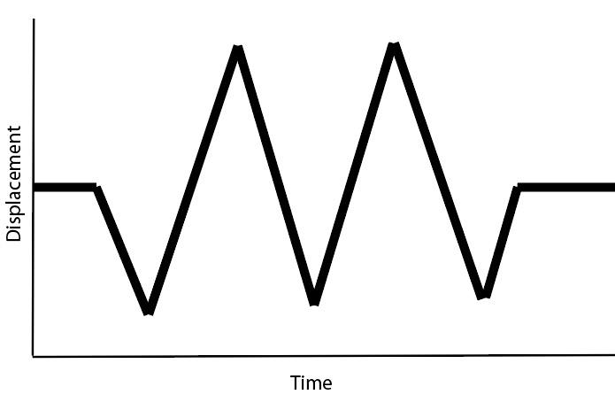
Seismogram 2: Finish the sentence. The ground at the seismometer...

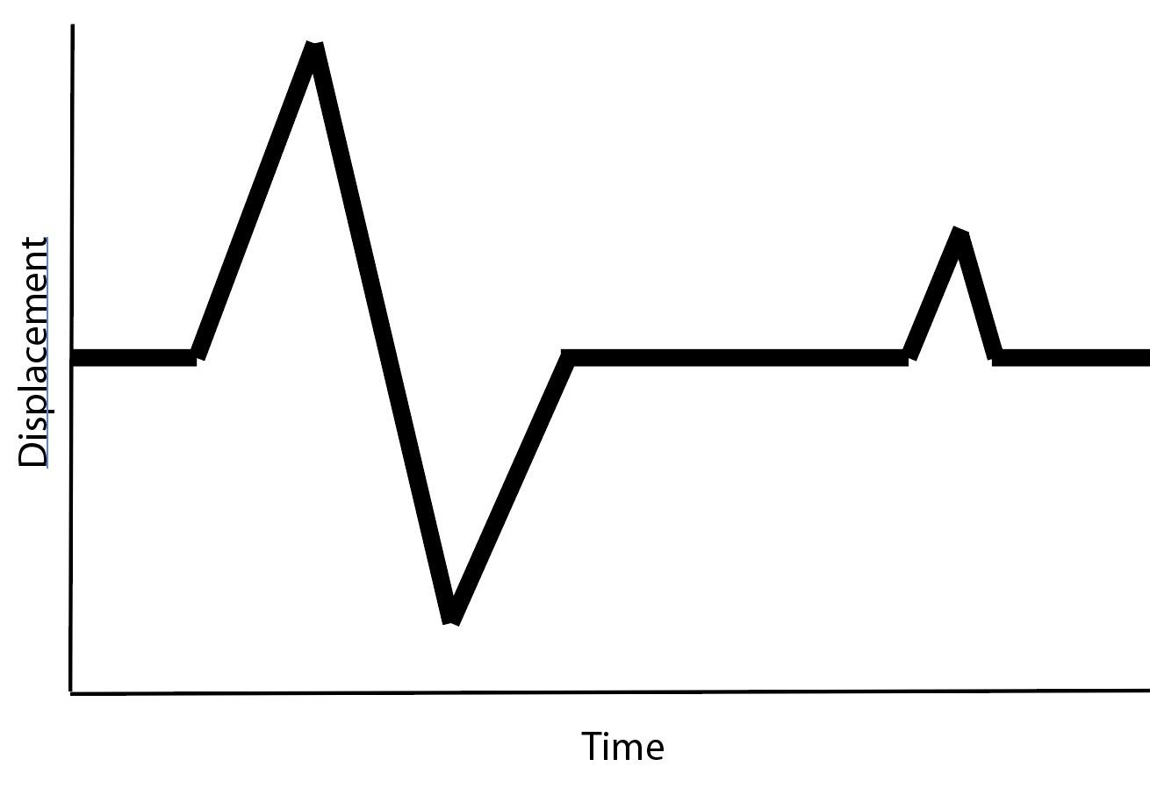

Seismogram 3: Finish the sentence. The ground at the seismometer...

Next, let's look at some seismograms that are a bit more complex. While still artificial, these are a bit more realistic.
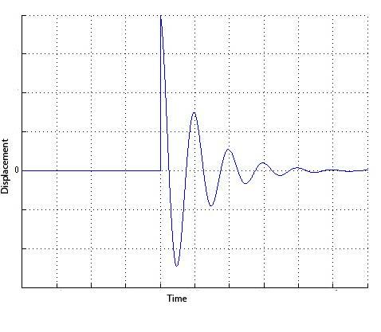
Seismogram 4: More generally (in 2 sentences) describe the ground motion:

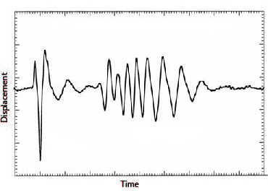
Seismogram 5: Compare this seismogram to seismogram 4 above. In 2-3 sentences describe the ground motion.

Finally, let's look at a real seismogram from an earthquake. You will notice that this example is the most complex yet. However, it still corresponds to the ground motion at the seismometer.
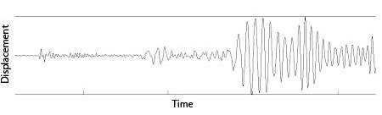
Seismogram 6: Examine this seismogram carefully and compare it to seismograms 4 and 5 above. What patterns do you see? Do you see particular times when the ground is moving up and down differently than other times? In 2-3 sentences, describe what makes this seismogram different from the others.

Section 2: How sensitive is a seismometer?
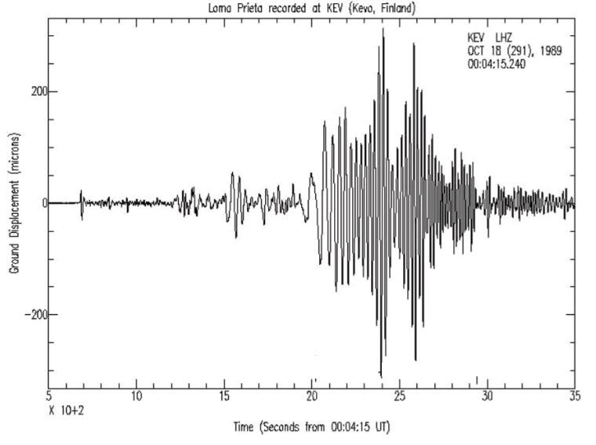
The single vertical seismogram below shows how the ground moved in Finland from a magnitude 6.9 earthquake that occurred in California. The x-axis represents time and the y-axis represents ground displacement.

- Use the internet to determine how far Finland is from California.

- Since we know that seismograms are recordings of ground motion at the seismometer, do you think people in Finland felt this earthquake? Explain why or why not.

Notice that the unit of displacement on the Y-axis of the seismogram is microns, or a unit of length equal to one millionth of a meter. To give you a sense of scale, a dime is roughly 1000 microns thick and the average human hair is roughly 100 microns thick.

- Based on this comparison and the seismogram provided, what was the maximum movement of the ground where this seismogram was recorded in human hairs?

- Let's revisit your thinking from above, do you think people in Finland felt this earthquake? Explain why or why not.

- Watch this video of people experiencing an earthquake (https://www.youtube.com/watch?v=qQZa83IjFwU). The video includes a seismogram recorded at the same time the video was taken.

- Did the earthquake occur close to where the video was taken? Be sure to justify your answer using evidence.

Section 3: Is the Ground Moving Near You?
Has the ground moved recently near where you live? To find out, go to the IRIS Station Monitor (https://www.iris.edu/app/station_monitor/) and enter your zipcode to see a nearby station. When you do, you will see a continuous seismogram, or recording of vertical ground motion at that station. Each line shows one hour’s worth of ground motion. Note that the Time shown is based on Coordinated Universal Time (UTC).

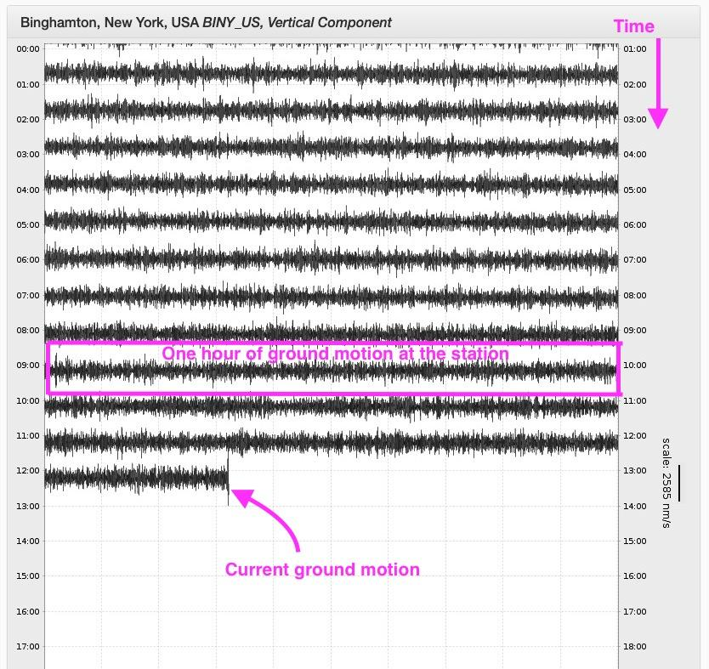

- Below, paste a screenshot of the ground motion from a station near you.

- Examine the ground motion from the seismometer near you and describe what you see in 2-3 sentences. For example, do you see regular repeating lines like the example above? Do you see anything that looks like the earthquake seismograms in the previous sections? Or, maybe you see some other ground motion that might be caused by some other source. While you may not be on a volcano, here are some examples of other things that cause the ground to shake. What might cause shaking near you? Cars? Trains? Quarry blasts?

- Ask a seismologist! What question do you have after looking at the seismograms from near where you live? (Teachers - send your students’ questions to epo@iris.edu and we are happy to answer!)

