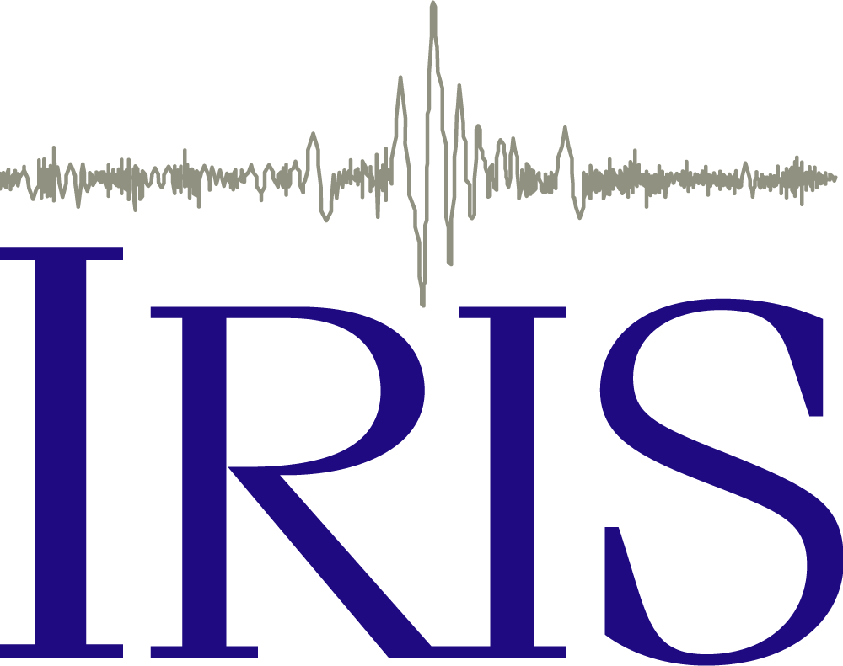 Reading Seismograms: Part 3

Ground Motion
- Watch the shaking experienced during this earthquake. You may wish to watch the clip several times. It is pretty amazing! https://www.youtube.com/watch?v=eqHCNpcL74I

- Watch the beginning of the clip to 0:29 second again. This time focus your attention on the light blue plastic trash can that is on the top shelf on the right side of the screen.

Which of the following best describes the shaking in the store? (Circle all that apply)

- Side to side (Front to Back)
- Side to side (Left to Right)
- Up and down
- None of the above

Did you choose A, B above to describe the shaking in the store? During an earthquake, the ground shakes in both of these directions… However it also shakes in a third dimension… up and down. This motion is difficult to detect because it isn’t strong enough to make anything fly into the air. However, if you watch closely at the beginning of the clip till about 0:03 seconds in, it is the first small shaking that knocks over a few items and alarms the woman. Lets explore this idea further...
- Modern seismometers record three different seismograms at each station as shown in this animation (https://www.iris.edu/hq/inclass/animation/115). Watch this animation and answer the following questions as you go.

In what way is each of the three different seismograms recorded from a single station the same as the others? In what ways is each different?

On which of the three seismograms would you expect to record an earthquake? (Check One)
- None of them
- Only the Vertical component
- Only the North/South component
- Only the East/West component
- All of them

Which component would best record P waves? Why?

Which component would best record S waves? Why?

Which component would best record Surface waves? Why?

Examples of Three-Component Seismograms
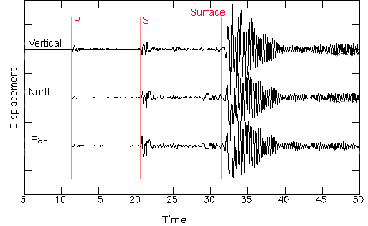
Example 1: A seismometer in Stanford, CA records a distant earthquake. These seismograms are the recordings of the three components of ground motion at this station. Each seismogram is labeled to indicate which type of motion it is recording. The seismograms have been labeled with the P, S, and Surface wave arrivals.

- Compare the labels for the arrival of the P wave, S wave and Surface waves compare to what you would expect based on your answer above. Are they similar or different? Use evidence from the seismograms and the video you watched to justify your choice.

Example 2: Another example of a distant earthquake recorded at seismograph in Riverside Co, California. Again there are three recordings of ground motion. However, this time the three components are in a different order. We have labeled P, S, and Surface wave arrivals.
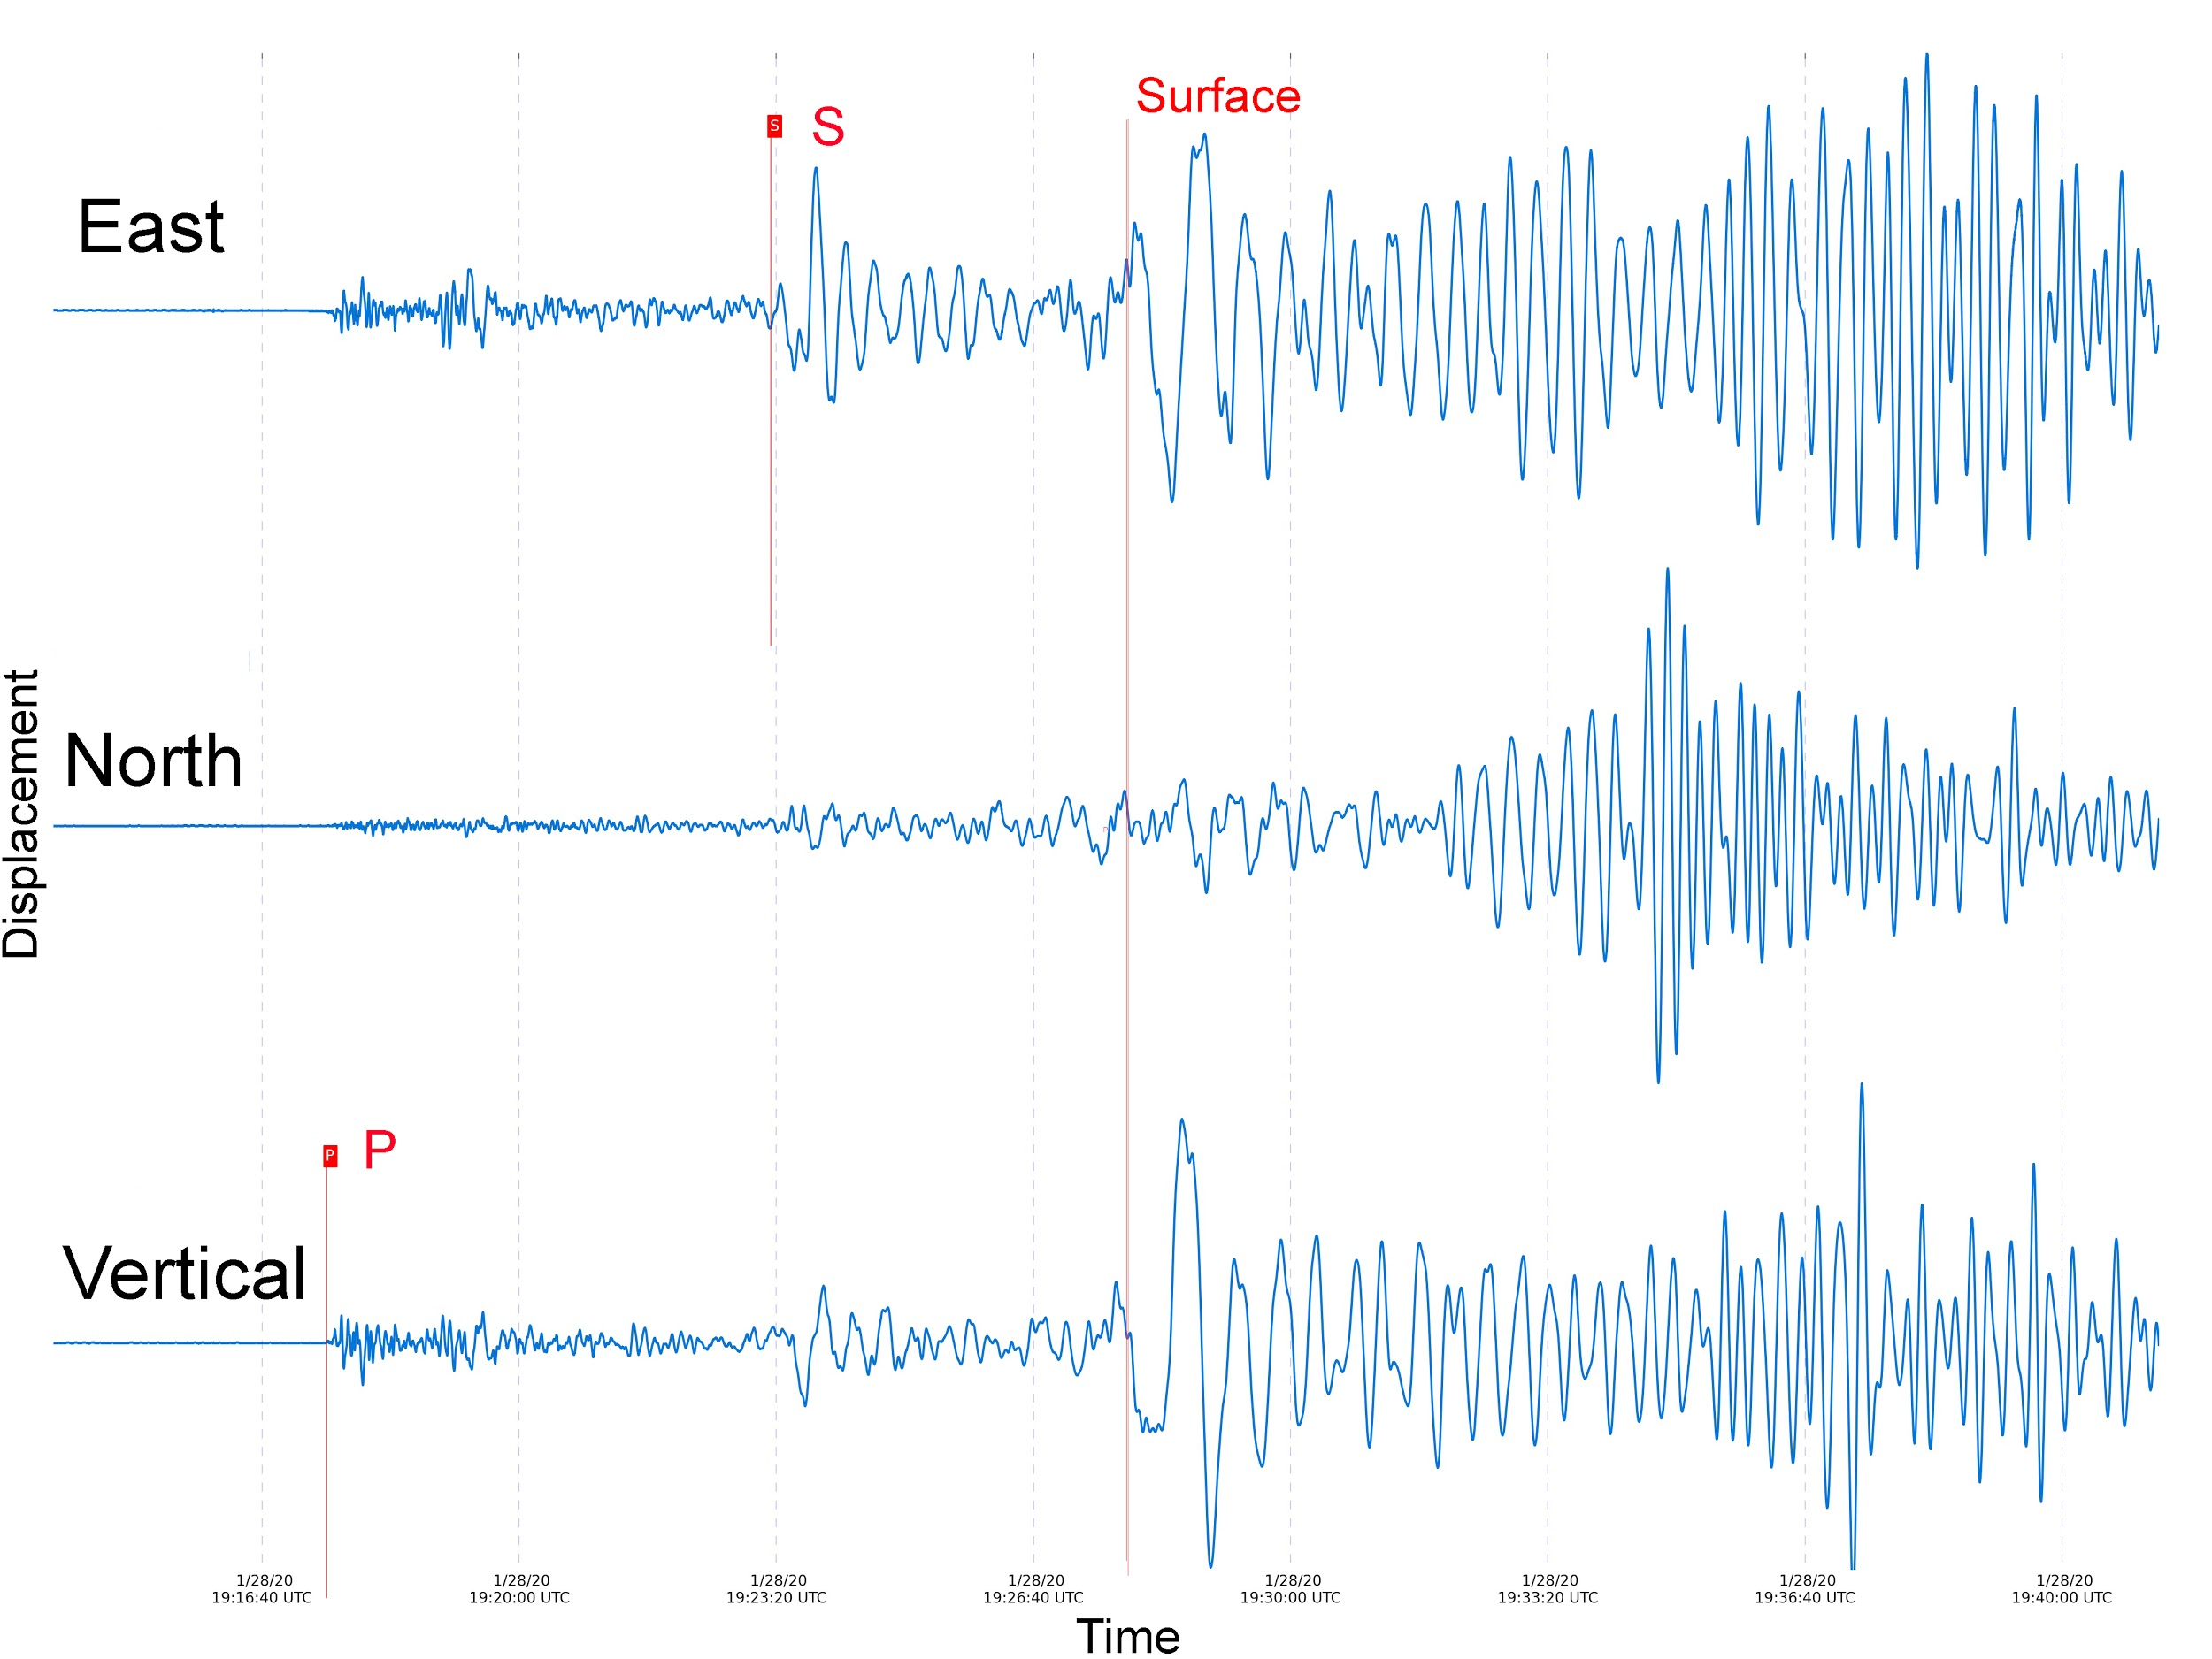

P waves are often the first arrival visible on the seismogram. Look at the trace prior to where the P wave is marked, the seismometer is quiet (flat) prior to the change in amplitude corresponding to the shaking of the ground as the P wave arrives.

S waves are more challenging to recognize. For earthquakes closer to the recording seismometer, S waves are generally the next large arrival.

If the event is large, distant, and not too deep, the seismometer will record surface waves.

Example 3: In this example, an earthquake was recorded nearby at station Southern California. Again there are three recordings of ground motion. We have labeled P and S wave arrivals.

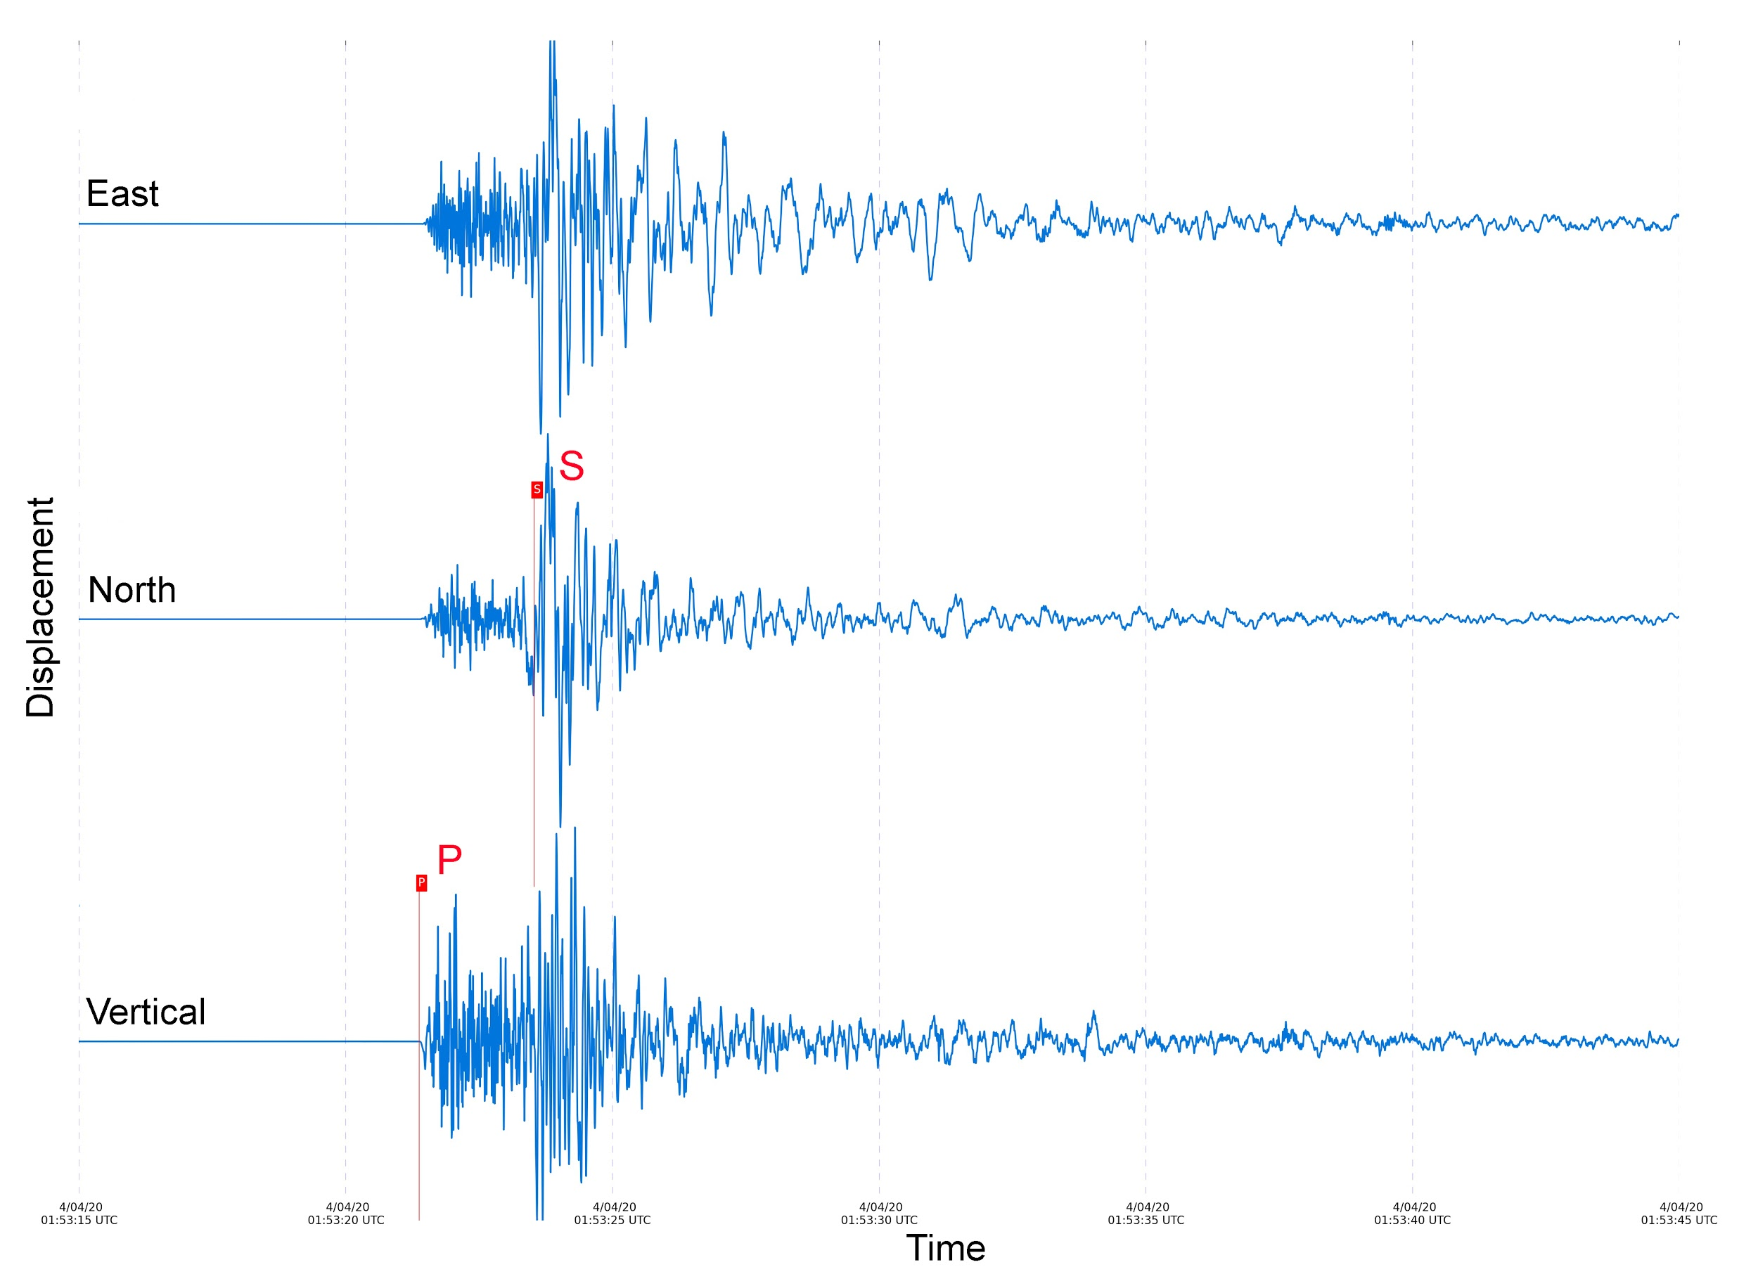

- Describe at least two ways the seismograms from a nearby earthquake (Example 3) differs from the previous seismograms (Example 2) where the seismometer was far away from the earthquake?

Single-Component Examples
To further explore factors that contribute to the shape of a seismogram, we are going to look at several more examples. However, to simplify things a bit we are only going to look at the vertical seismograms (though the ground did move in both other dimensions).

Wave Speed: Seismic waves travel at different speeds and this has an effect on the shape of seismograms. The P wave is the fastest wave. The S wave is the second fastest, and the surface waves are the slowest. When the earthquake is close to the seismometer, the P and the S wave arrive very close together because they haven’t traveled far enough for them to spread out. As the distance increases between the earthquake and the seismometer, since P waves travel faster than S waves, the distance between the arrivals increases. Take a look at this animation (https://www.iris.edu/hq/inclass/animation/693) and see how the P waves moves farther and farther from the S wave the further the waves travel.
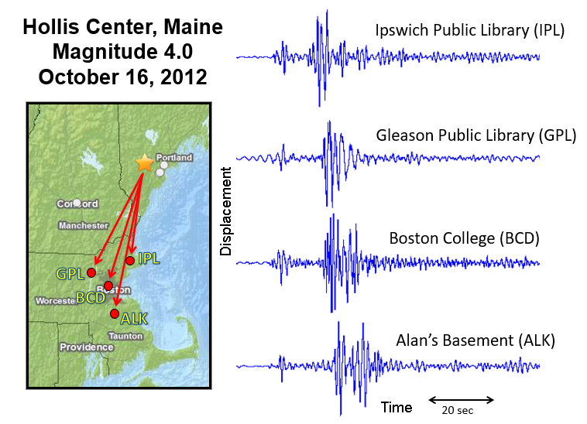
In the example at right, a magnitude 4.0 earthquake occurred in Maine (star on map) and was recorded at four east coast seismometers (red dots on map). The red lines show the path the waves traveled. Each seismogram shows a (smaller) P wave arrival and a larger S wave arrival. Note how the space between the P and S waves arrivals increases as the distance from the station to the earthquake increases. This difference in wave speed is also used to save lives by providing an alert to the public (https://www.iris.edu/hq/inclass/animation/shakealert_earthquake_early_warning_system)!
Images courtesy of Alan Kafka https://akafka.wordpress.com/

Dispersion/Energy Loss: The second reason that seismograms look different with distance is due to the loss of energy as the waves travel. Remember, as earthquake waves travel energy is lost. This occurs both because it is spread over a larger and larger area, like ripples on a pond (https://www.iris.edu/hq/inclass/video/wave_propagation_ripples_on_a_pond). We call this dispersion. In addition to dispersion, seismic energy is not transferred with 100% efficiency, which means that some energy is lost to things like friction, etc.

The example seismograms below show a magnitude 6.0 earthquake that occurred in California. The seismograms illustrate how the ground moved vertically in Arizona (top) and Massachusetts (bottom). On the Arizona seismogram, the P and S wave arrivals are visible as the seismograms are much larger (more energy). However, it is much more difficult to see arrivals on the Massachusetts seismogram as much of the energy has been dispersed or lost resulting in smaller amplitude wiggles.

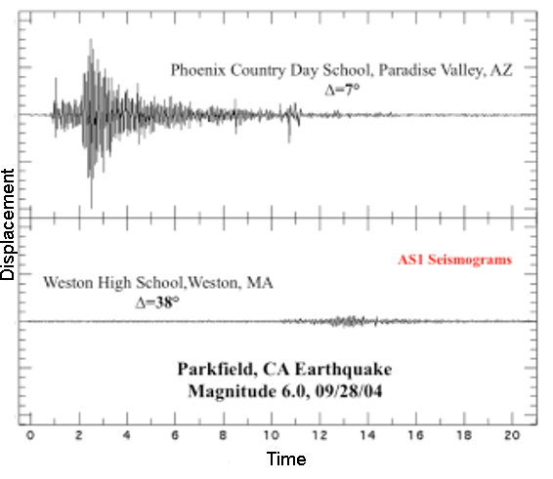
Image courtesy of Alan Kafka https://akafka.wordpress.com/

Let’s Create!
On the map we have the locations of two seismometers marked, one in Alaska and one in South America.
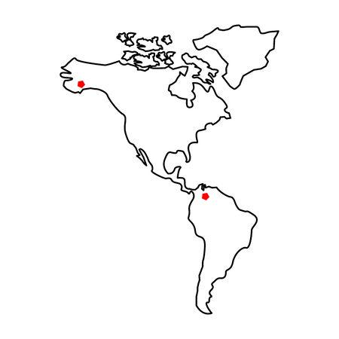
- Create an earthquake! Mark an X on the map where your earthquake occurred. Your choice, your earthquake!

- Is your earthquake in a location where earthquakes would be expected to occur? Why?

- On the blank seismogram below, draw what you think might be recorded on the three component seismogram in Alaska from your earthquake. Label your P, S, and Surface waves. (Remember to think about which components different wave types are best recorded on.)
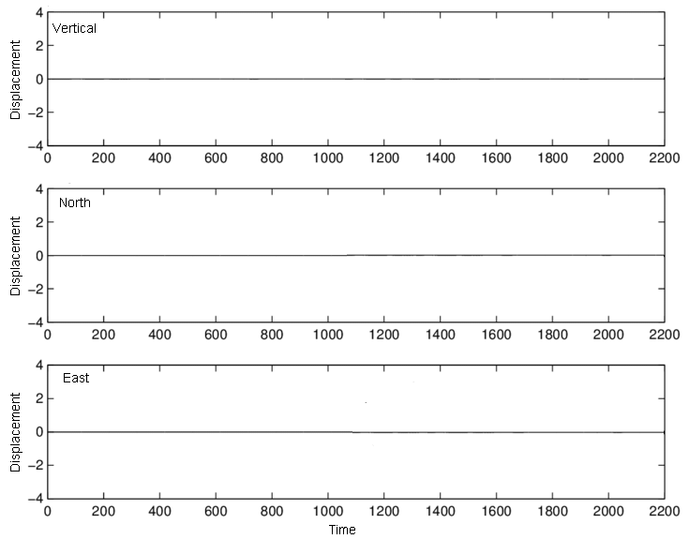

- On the blank seismogram below, draw what you think might be recorded on the three component seismogram in South America from your earthquake. Label your P, S, and Surface waves.
- What considerations went into your record of ground motion at these two stations from your earthquake? How did relative distance, wave speed, and dispersion contribute to each seismogram?

