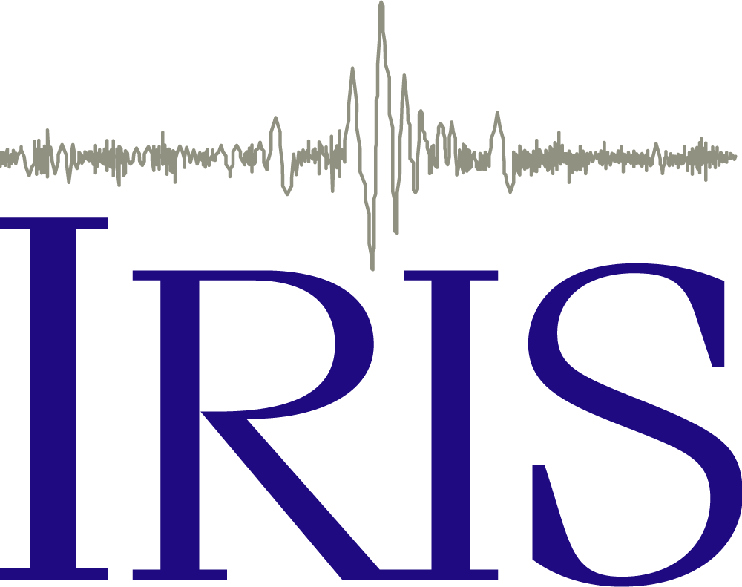 Seismic Waves!
You may have heard that the Earth as a layered interior. Have you ever wondered how we know? What evidence do we have?

Let’s Learn Some Basics About Seismic Waves
- Watch the animation https://www.iris.edu/hq/inclass/animation/p_wave_vs_s_wave and answer the following questions.
- Which of the following best describe how a P wave moves?
  - Particles move in elliptical movements
  - Particles move in the same direction the wave is propagating
  - Particles move perpendicular to the direction the wave is moving
- Which travels faster?
  - P waves
  - S waves
  - Neither, they travel the same speed
- How does the gap between the P and S wave change the farther the seismic waves travel?
  - It doesn’t change
  - It becomes larger
  - It becomes smaller
- When recorded, the arrival times of the P wave and the S wave provide information about which of the following?
  - The size of the earthquake
  - How many people felt the earthquake
  - How far away the earthquake occurred

- Watch the animation (https://www.iris.edu/hq/inclass/animation/1component_seismogram_building_responds_to_p_s_surface_waves) and answer the following questions.
- In this animation, how long did it take the P wave from a distant earthquake to arrive to the recording seismometer?
- Less than 10 minutes
- Between 10 and 20 minutes
- Between 20 and 30 minutes
- Between 30 and 40 minutes
- More than 40 minutes

- In this animation, how long did it take the S wave from a distant earthquake to arrive to the recording seismometer?
  - Less than 10 minutes
  - Between 10 and 20 minutes
  - Between 20 and 30 minutes
  - Between 30 and 40 minutes
  - More than 40 minutes
- How long does it take the Surface waves to arrive?
  - Less than 10 minutes
  - Between 10 and 20 minutes
  - Between 20 and 30 minutes
  - Between 30 and 40 minutes
  - More than 40 minutes
- Which type of seismic waves shake a building with mostly a shearing or back and forth motion?
- Surface waves
- P waves
- S waves

Let’s Explore A Special Earthquake
On December 26, 2004 a magnitude 9.1 earthquake occurred at a depth of 30 km in Sumatra. This is the earthquake we will be using in our simulation.

- Use the following figure to estimate how often earthquakes of this size occur:

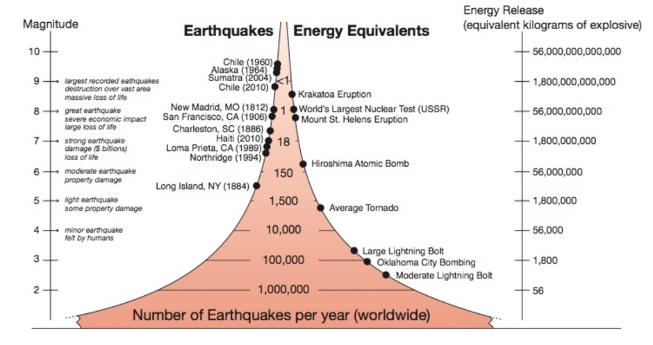

Watch the Seismic Waves from this earthquake!

- Open the Seismic Waves Viewer app http://ds.iris.edu/seismon/swaves/

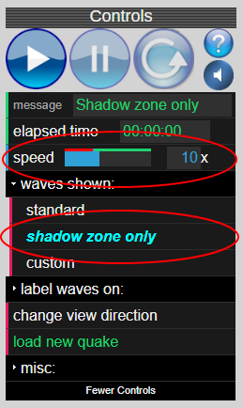
- Go to the control panel on the right. Select Waves Shown > Shadow Zone Only. This will simplify the display.

- Also, in the control panel, use the mouse to slide the blue bar over to 10 x. Use this slower setting for first-time viewing. Once you have watched it several times, you can use faster settings for comparing different earthquakes.

- Click the Play Button to start the simulation and watch as the waves spread across the surface of Earth and through its interior.

- You can view different parts of Earth and its interior by clicking and dragging the globe with your mouse.

While watching the seismic waves move through Earth, answer the following questions:
- Using the key on the simulation, what do the colors of lines on Earth represent?
  - Red:
  - Light Blue:
  - Yellow:

Rotate the globe so that you can see Earth’s surface and press the Reset Button to reset the simulation. Now let’s look at a few more things in detail.

- Watch the first red and blue line closely. Over time, what happens to the distance between the first red line and the first blue line as they move across the surface of the globe?

- Using what you know about seismic waves (hint, think back to the animations at the beginning) why does this happen?

Reset the simulation again. Make sure the globe is rotated so you can still see the surface.

- Watch the seismogram CHTO (far left) carefully. Once the seismogram reaches 15 minutes (don’t worry, remember we sped up the waves 10x, this will only take 1 minute 30 seconds), click the pause button and sketch the CHTO seismogram in the space below.

- Notice how the amplitude of the displacement on the seismogram are much larger than others. Compare the seismogram to lines on the Earth’s surface. What type of waves are causing the largest movement of the ground at the station CHTO?

- Look at the seismograms again. About how long did it take for the P waves to reach station RAO?

Reset the simulation again. Make sure the globe is rotated so you are looking at a cross-section of the interior.
- Which waves leave the earthquake first? Which are second?

- What happens to the P waves when they reach the outer core?

- What happens to the S waves when they reach the outer core?

Let’s Review
- Watch a review of how seismic waves travel through the Earth. https://www.youtube.com/watch?v=rspUJRjoCQs&t=311s Are there more waves traveling through the Earth than you thought there were?

- Watch the animation: https://www.iris.edu/hq/inclass/animation/seismic_shadow_zone_basic_introduction
- Watch the animation: https://www.iris.edu/hq/inclass/animation/seismic_shadow_zones_vs_light_shadows

- Think back to your observations about what happened to the S waves when they reached the outer core. Why did this occur?

- How might this observation provide evidence that Earth has layers in its interior?

