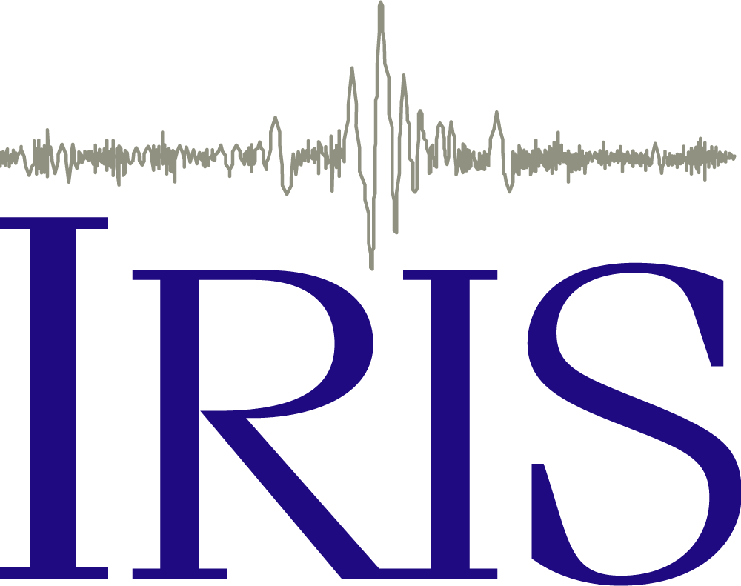 Exploring Earthquake Shaking

Earthquake Damage
While the magnitude of an earthquake is an important way to describe an earthquake, it doesn’t tell the whole story of how a community might experience an earthquake. You see, magnitude describes the total amount of energy released from the earthquake. However, the amount of damage to buildings and infrastructure during earthquakes relates more to local ground motion (e.g. shaking) than to the magnitude of the earthquake. And, the degree of shaking can vary considerably from place to place during the same earthquake due to a variety of factors that we will explore. We can measure the degree of shaking several ways but today we will focus on one metric… peak ground velocity. Understanding peak ground velocity can help with earthquake preparedness for seismic design and retrofitting of existing structures.

If we define velocity as the speed of an object in a given direction, then in an earthquake, velocity is how fast a point on the ground is shaking as a result of the earthquake. So, peak ground velocity is the greatest speed of shaking recorded at particular point during an earthquake. However unlike magnitude, this value varies from place to place for the same earthquake.

In past weeks, we have looked at what seismometers record during an earthquake. They are recording how the ground moved as seismic waves arrived. If you experienced an earthquake, how would it feel? While it would depend on the size of the earthquake and how far away it occurred, what you feel would also depend on what was beneath your feet.

Explore
We are going to explore a simulated magnitude 7.7 earthquake in the central United States in the seismically active New Madrid Seismic Zone. Before watching the animation, answer the following questions based on this screenshot:
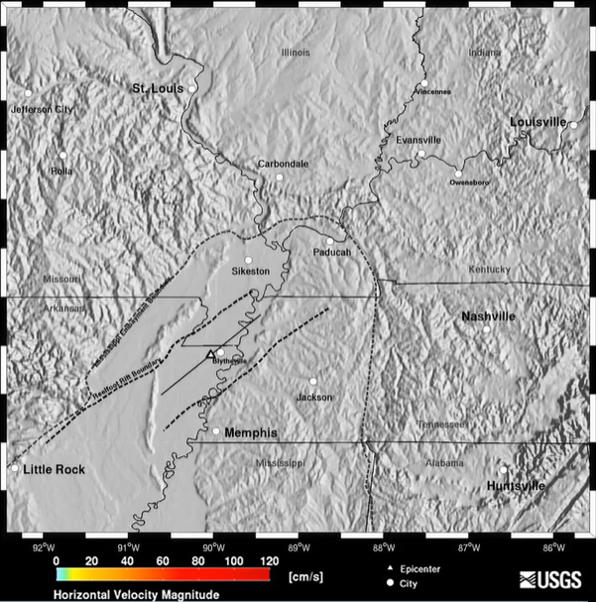

- Look at the shaded relief map and describe the topography of the region. Is the ground flat? Hilly? Both? What is your evidence?

- The color scale at the bottom represents the peak ground velocity at the surface, which means, the higher the value, the higher the speed of shaking. What color represents the fastest shaking? What color represents the slowest shaking?

Watch the simulated magnitude 7.7 earthquake in the New Madrid Seismic Zone (a few times) https://earthquake.usgs.gov/scenarios/related/nmszM7.7.php.

- After the simulated earthquake, in which directions do the seismic waves travel?

- Describe the patterns of peak ground velocities after the earthquake. Is the peak ground velocity consistent in all directions? Are there areas of higher peak ground velocity than others?

- Look at a map of the area, what feature is contributing to both the smooth flat land at the lower left corner of the simulated earthquake map and the higher peak ground velocity following this earthquake?

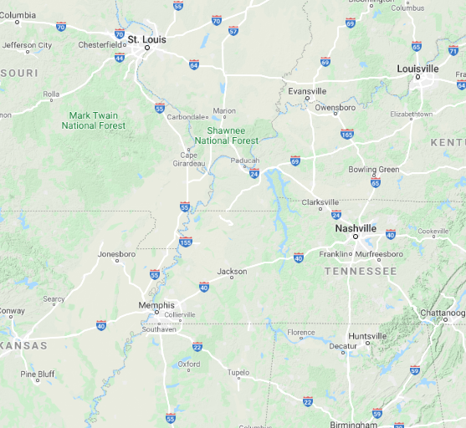
(https://goo.gl/maps/GkijLvNbgES8Zn13A)
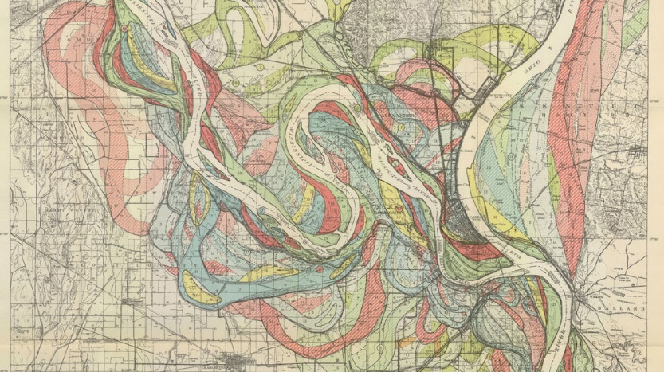
While the Mississippi River looks relatively small on the google map where it passes by Memphis, Tennessee, it has had a big impact on the region. Did you know just how widely the Mississippi changed course in its past? Take a look at the full map of the Mississippi River in this NPR article. (https://www.npr.org/sections/inside/2010/07/14/128511984/twisted-history-the-wily-mississippi-cuts-new-paths)

Amplification
Let’s explore a little deeper into what is happening in the New Madrid Seismic Zone. Why is there amplification of the seismic waves leading to higher peak ground velocities in the lower left of the region?

Watch this animation: https://youtu.be/536xSZ_XkSs
(https://www.iris.edu/hq/inclass/animation/111)

- Do seismic waves travel at the same speed through the different materials? If yes, in what materials? And if no, why not?

- Do seismic waves travel with the same amplitude through the different materials? If yes, in what materials? And if no, why not?

- Which environment has more destructive seismic waves? (Select one)
  - Bedrock (high-frequency low-amplitude waves)
  - Sediment (low-frequency high amplitude waves)

- Let’s put this all together! How do these concepts relate back to the magnitude 7.7 simulation?

