What does it take to create a big quake?
Watch the trailer for the TV mini-series 10.5
https://www.youtube.com/watch?v=rivOwpV9LJE

Based on the trailer, what do you think happens in this show?

What you think the title “10.5” refers to? Provide evidence from the clip to support your answer.

Study the graph below and answer the following questions

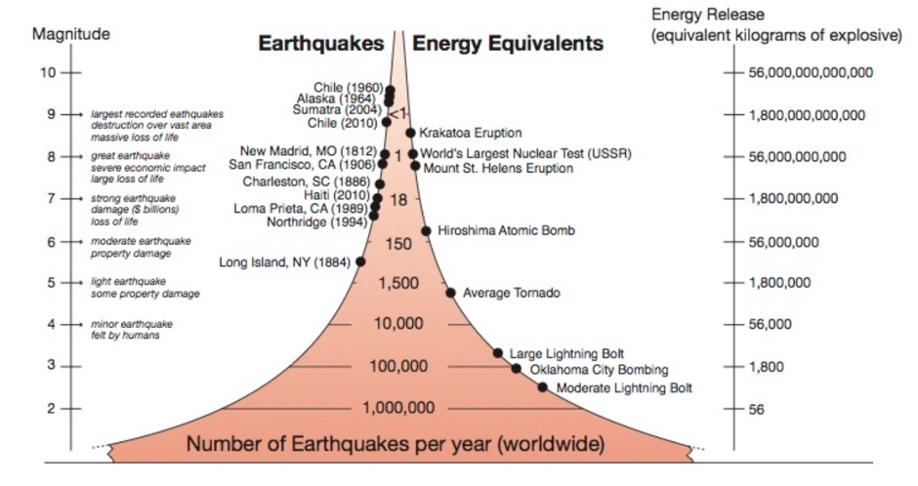

What types of information can you gather from this graph?

Using examples, describe the relationship between Magnitude and the Energy Released.

Based on the information in the graph, do you think the 10.5 mini-series is fact or fiction? Support your answer with evidence.

Next, let’s explore what factors contribute to the Magnitude, or energy release, of an earthquake. To do this we will look at an interactive earthquake simulator which is a computer model of an earthquake. This model uses a mathematical formula to calculate the Magnitude of an earthquake using a given set of factors. You will be able to investigate these factors by changing them and exploring the impact each of them has on the Magnitude of an earthquake.

https://www.iris.edu/app/10.5/

List and define each of the four factors that you can manipulate in this model

Factor 1 -

Factor 2 -

Factor 3 -
Factor 4 -

Using the model
To use the model, you will set each factor to some value and then press “calculate”. The model will then predict an expected magnitude if an earthquake were to occur given the factors you set. Today we will complete 10 trials with the simulator.

Step 1: Set the four factors to any value you wish and record each setting in the table below.
Step 2: Before you press “calculate” estimate (guess) what magnitude will result from the simulation (you might refer back to the figure above) and record that in the table below.
Step 3: Finally, press “calculate” and record the magnitude predicted by the computer model

Trial | Length  (km) | Width  (km) | Slip  (m) | Rigidity | Your Estimated Magnitude | Calculated  Magnitude
1
2
3
4
5
6
7
8
9
10

Describe what settings you used in the model to create the largest earthquake in your trials. What was the magnitude of that earthquake?

Describe what settings you used in the model to create the smallest earthquake in your trials. What was the magnitude of that earthquake?

Complete the following sentences to describe the relationship between each factor and the magnitude of the earthquake assuming all other factors did not change?

As fault length increases, the magnitude of the earthquake _____________.

As fault depth/width increases, the magnitude of the earthquake _____________.

As fault slip decreases, the magnitude of the earthquake _____________.

As rigidity/strength of the material the fault is in increases, the magnitude of the earthquake _____________.

Now let’s think about how all the factors interact together. Mathematically, does Multiplying or Dividing best describe the relationship between the factors and the earthquake magnitude? Justify your answer from your trials above.

Were all the earthquakes you made with this model realistic? What implications might that have for the way we think about and use computer models? Support your response with data from the earthquake simulator.

‘Based on the results you got, should we be concerned about an earthquake like the one in 10.5? Justify your response.

