How Big of a Quake Can You Make?
How could you create your own earthquake? In the space below, describe what you would “do” to make one!

Earthquake Energy
An earthquake is the sudden release of stored energy as one side of a fault slips relative to the other. The amount of energy released is described as Magnitude. As you can see in the figure below, a Magnitude 2 earthquake is equivalent to the energy released from 56 kilograms of explosive. The energy equivalence increases by 32 times for each step up on the Magnitude scale. Thus, a Magnitude 3 earthquake would be equivalent to the energy release from 56 kilograms x 32 = the energy release from ~1800 kilograms of explosives.

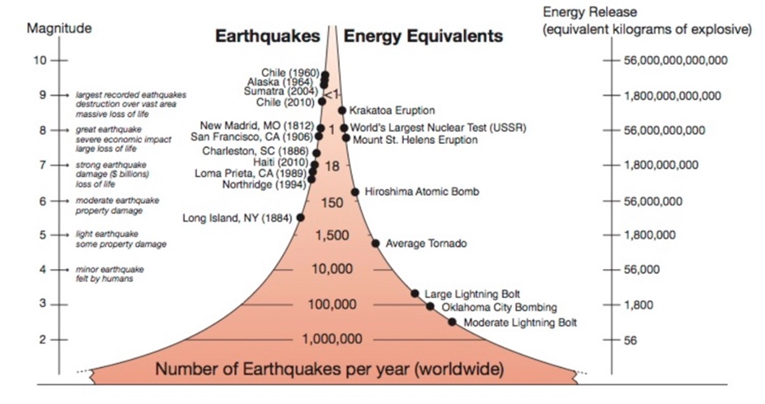

Based on the figure above, approximately how many earthquakes occur each year that release the equivalent of 56,000,000,000 kilograms of explosives?

Approximately how many earthquakes occur each year that release the equivalent of 1800 kilograms of explosives?

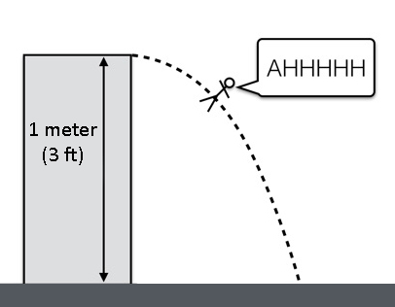
How big of a Quake can you make?

How did you propose to create your own earthquake? One possibility is to jump off a chair onto the floor. (**Make sure you have permission before creating an earthquake in your home!!) The energy you have standing on the chair (stored energy called potential energy) is released and transferred to the floor when you jump. This is similar to (but not exactly the same as) the stored energy of a fault being released to the surrounding ground as one side slips relative to the other.

Consider an earthquake that you could make by jumping off a chair onto the floor. Before we begin, predict what size earthquake this jump would create?

Initial predicted magnitude of my jumpquake_____________________________

Calculate!
We can calculate your Potential Energy (PE), or the energy stored internally in you while in an elevated position with a simple formula:

PE (joules) = mass X height X gravity constant

Mass = You! We will use 50 kg which is approximately 110 pounds
Height = The height of your chair! We will pretend the chair is about 1 meter (about 3 ft) high. That would be a really tall chair but it makes the math easier.

Gravity constant = You might think of this as the effect of Earth’s gravity on every object. This is normally 9.81 m/s² but for our purposes we will us use 10 m/s² to simply the math again.

Joules = A unit of measure for energy.

Putting it all together…. So if you climb up on a chair 1 meter (about 3 ft) high, and we assume your mass is about 50 kg (110 pounds), and we assume the gravity constant is 10 m/s², how much potential energy do you have?

Potential Energy (in joules) = 50 kg X 1 m X 10 m/s²

= _____________ joules (kg x m²/s²)

You have just calculated the Potential Energy you have when standing on the chair! When you jump off this chair your potential energy will be converted to kinetic energy or the energy a moving object has as a result of its movement. When you hit the floor, the kinetic energy is converted to heat and seismic waves moving away from your feet

Similarly, the energy release from an earthquake can also be calculated based on physical features (like your mass and height above). However, in an earthquake, the physical features are of the fault: the length, width, displacement, and rock strength. Potential energy is stored in the crust in the form of elastic energy due to built-up stress in the rocks.

Magnitude | Energy in joules
-3.0 | 2
-2.5 | 11
-2.0 | 63
-1.5 | 350
-1.0 | 2000
-0.5 | 11000
0.0 | 6.3 x 10⁴
0.5 | 3.6 x 10⁵
1.0 | 2.0 x 10⁶
1.5 | 1.1 x 10⁷
2.0 | 6.3 x 10⁷
2.5 | 3.5 x 10⁸
3.0 | 2.0 x 10⁹
4.0 | 6.3 x 10¹⁰
5.0 | 2.0 x 10¹²
6.0 | 6.3 x 10¹³
7.0 | 2.0 x 10¹⁵
8.0 | 6.3 x 10¹⁶
9.0 | 2.0 x 10¹⁸

Estimate your Magnitude!
We can use this table (right) to estimate the magnitude of your jumpquake based on the energy you calculated. Let’s explore the table.

What is the largest magnitude shown?

What is the smallest magnitude shown?

Approximately how much energy is released for a Magnitude 0 earthquake? (YES, there can be Magnitude 0 earthquakes and even negative Magnitude earthquakes! They are very, very small and not felt by humans!)

How much does the energy increase by for each step in magnitude? (Calculate this by choosing a magnitude and dividing its energy by the energy of the next magnitude smaller. Round your answer to the nearest whole number.)
Adapted from Denton, P. (n.d.). Earthquake magnitude calculations. Retrieved June 11, 2020, from https://www.bgs.ac.uk/discoveringGeology/hazards/earthquakes/magnitudeScaleCalculations.html

Using the value you calculated for your Potential Energy from jumping off the chair, estimate your jumpquake’s magnitude.

Estimated jumpquake magnitude ___________

How close was your Initial predicted magnitude of my jumpquake (from page 2) to your answer above?

Describe what you could do differently to make your jumpquake’s a magnitude larger?

Let’s all jump together!
How many 90 kg people (mass of an average American male), all jumping 0.3 m (12 inches), would it take to release the energy of a magnitude 1 earthquake?

Does your estimate fit with the following story about excited sports fans in a ~69000 seat stadium. Why or why not?
https://www.nbcnews.com/science/weird-science/seah awks-kamquake-rattled-seattle-beast-quake-still-rules-n284871

