Frequency-Magnitude data for California and Nevada earthquakes, 1960 – 2007

L. Braile, October, 2007 (revised November, 2008)


Recurrence intervals of earthquakes and rates of seismicity can be determined using Frequency-Magnitude data and graphs. The Frequency-Magnitude relation is a universal characteristic of earthquake activity and can be applied to global, regional and local areas (subject to historical and instrumental recording data limitations). The Frequency-Magnitude relation is sometimes called the Gutenberg-Richter relation, named after two famous seismologists who first described it.

One can easily calculate the data for a Frequency-Magnitude plot using the Seismic-Eruption program by selecting an area and then using the counter to determine the number of events (in the area and time period selected) of magnitude greater than or equal to a selected magnitude cutoff. Repeating for the total range of magnitudes provides the required data. The data can then be plotted by hand on semi-log graph paper or using Excel or other graphing software. An example is shown below using magnitude cutoffs of 2.0, 2.5, 3.0, etc., and the 1960-2007 earthquake data (data table on right) for a selected area (map on left from Seismic-Eruption) of California and Nevada. Note that the number of events is the same for magnitudes 2.0, 2.5 and 3.0. This result is due to the limitation of the earthquake catalog – only M3 and larger earthquakes are included. Even when very small earthquakes are included in such catalogs and analyses, the number of events for small magnitudes is often smaller than the true occurrences of earthquakes because not all small events are recorded, located and the magnitude determined. This situation is referred to as a catalog being “incomplete” for very small earthquakes. It is also possible (even likely) that the catalog can be incomplete for very large earthquakes due a relatively short historical record of earthquakes.

The frequency of earthquakes per year is given in the third column (by dividing the total number in column 2 by 47.75 years, the time period selected, 1/1/1960 to 9/30/2007). The resulting Frequency-Magnitude plot is shown below in both linear and semi-log scale. Note that using the linear vertical axis scale (for the number of earthquakes per year) it is impossible to precisely interpret the number of events per year for magnitudes greater than about M5. The plot with the logarithmic vertical axis scale allows us to interpret the data points for all magnitudes. Furthermore, the logarithmic scaling results in an almost perfect straight line relationship of the frequency-magnitude data.

Notice the approximately straight line relationship for the log scale plot. The line can be used to estimate recurrence intervals. For example, for magnitude 6 and above, the line indicates a value of just less than one event per year, actually about 0.8. Therefore, statistically, we would expect an M6+ earthquake in this area about once every 1.25 years (1/0.8).

Using the graph, how many M8+ events would you expect per year in this area?

What is the recurrence interval for M8+ earthquakes for this area?

Magn. (M) | Events M+ | Events/ Yr M+
2.0 | 22635 | 474.0314
2.5 | 22635 | 474.0314
3.0 | 22635 | 474.0314
3.5 | 8002 | 167.5812
4.0 | 2765 | 57.9058
4.5 | 961 | 20.1257
5.0 | 382 | 8.0000
5.5 | 125 | 2.6178
6.0 | 31 | 0.6492
6.5 | 11 | 0.2304
7.0 | 4 | 0.0838
7.5 | 0
8.0 | 0
Frequency-Magnitude data for earthquakes from 1960-2007 (47.75 years) for the California-Nevada region (see Seismic-Eruption map).
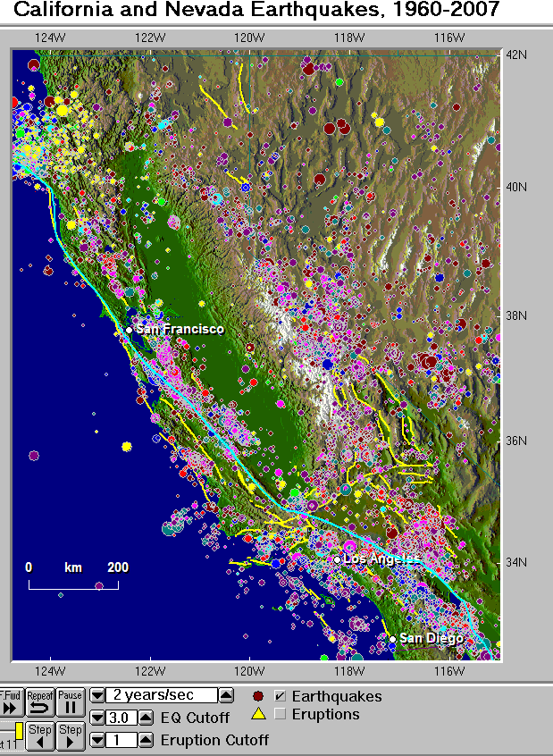
Seismic Eruption map of earthquakes in the California-Nevada area for 1960-2007.

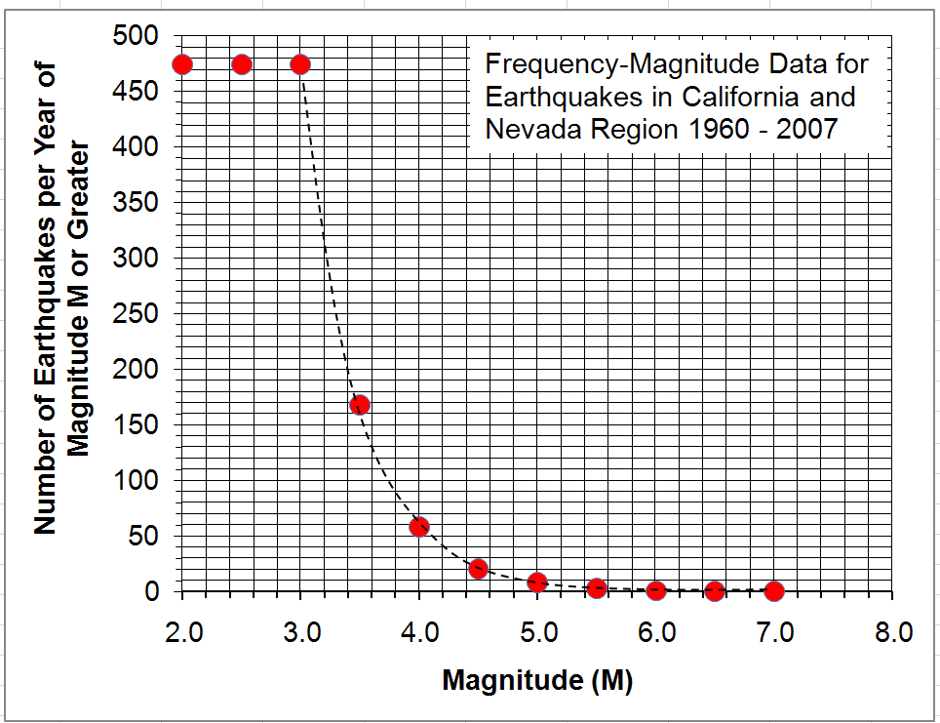
Frequency-Magnitude data for earthquakes in the California-Nevada area from 1960-2007 plotted with a linear vertical axis scale.

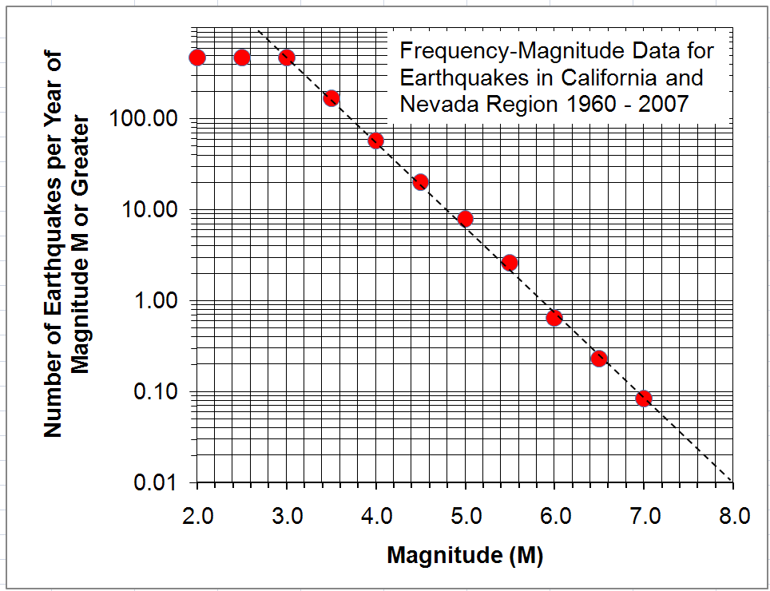
Frequency-Magnitude data for earthquakes in the California-Nevada area from 1960-2007 plotted with a logarithmic vertical axis scale.

References:

Barker, J. S., Student-centered experiments with earthquake occurrence data, The Earth Scientist, v. 21, Spring, p. 21-23, 2005.

Field, E.H., K.R. Milner and the 2007 Working Group on California Earthquake Probabilities, Forecasting California’s Earthquakes—What Can we Expect in the Next 30 Years?, US Geological Survey Fact Sheet 2008-3027, 2008 (http://pubs.usgs.gov/fs/2008/3027/fs2008-3027.pdf).

Stein, Seth, and Michael Wysession, An Introduction to Seismology, Earthquakes, and Earth Structure, Blackwell, Malden, MA, 498 pp., 2003.

The 2007 Working Group on California Earthquake Probabilities, The Uniform California Earthquake Rupture Forecast, Version 2 (UCERF-2),US Geological Survey Open File Report 2007-1437, 2008 (http://pubs.usgs.gov/of/2007/1437/of2007-1437_text.pdf).

